Formulae that are highlighted in green will be given in the exam, unless they are to be derived.

06 Curve-Fitting & Interpolation

Experimental data is usually **discrete**, having been performed for discrete set of data points.

Oftentime we need to approximate these data with a function that can be used to **extrapolate** the data (give data outside the range of measurement) or indeed to estimate the behaviour of the function for a change in function parameters. This process is called **curve-fitting**.

We can choose a curve that does not pass through most of the data points exactly, but does give a good picture of the overall behaviour of the data. Knowing the function, we can extrapolate the data and see how it would behave for a change in parameters.

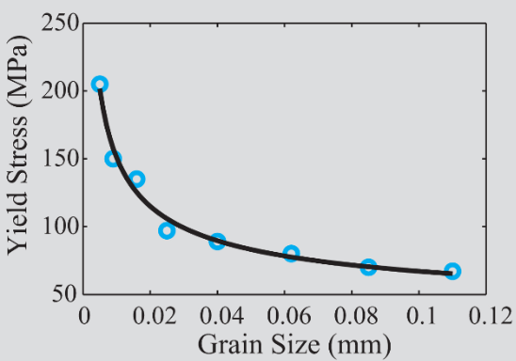

Oftentimes, we need to estimate the value of the function **between data points**. This is done by finding a function or functions that **fit the data exactly**. This process is called **interpolation**.

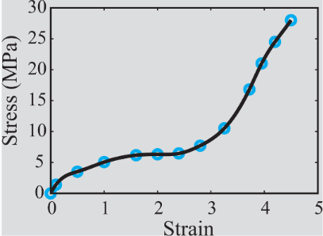

Interpolation is used to find **intermediate values**. Interpolation can be also be done on the basis of curve-fitting but the answer will not be as accurate.

# Curve-Fitting with a Linear Equation

The simplest curve fit is a line. The is done when it is expected that the experimental variables are **proportional** to each other.

The equation of a line (first-degree polynomial) is:

$y=a_{1}x+a_{0}$

We need to determine the constants $a_{1}$ and $a_{0}$, but first we need a definition of best fit, since a number of different lines might appear to fit the data well.

### The Residual

We define the **residual** as:

$r_{1}=y_{1}-{f(x}_{i})$

which is simply the difference between the data point $y_{1}$ and the value of the function ${f(x}_{i})$ used to approximate it.

### Total Error

A criterion that measures how well the approximating function fits the given data can be obtained by calculating the **total error $E$** . This can be calculated a number of different ways.

This simplest way is to **add the residuals** over all data points:

$E=\sum_{i=1}^{n}{}r_{i}=\sum_{i=1}^{n}{}\left[y_{1}-(a_{1}x_{i}+a_{0})\right]$

The total error does **not** give a good measure of the overall fit. This is because a bad fit with large positive and negative residuals may yield a small overall error.

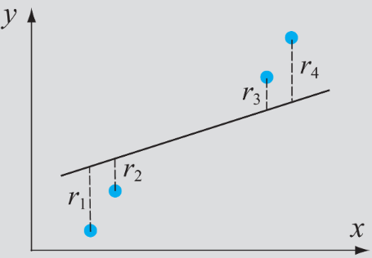

A way to circumvent this problem, is to make overall error equal to the sum of the **absolute values** of the residuals:

$E=\sum_{i=1}^{n}{}\left|r_{i}\right|=\sum_{i=1}^{n}{}\left|y_{1}-(a_{1}x_{i}+a_{0})\right|$

This can be a useful approach, however it now cannot be used to obtain the values of $a_{1}$ and $a_{0}$. The measure is **not unique**, meaning that for the same set of data points there can be several functions that give the same overall error.

A **good measure** for the overall error $E$ that can be used to obtain a unique line of best fit is obtained by making $E$ equal to the **sum of the squares** of the residuals:

$E=\sum_{i=1}^{n}{}r_{i}^{2}=\sum_{i=1}^{n}{}{\left[y_{1}-(a_{1}x_{i}+a_{0})\right]}^{2}$**(6.6)**

With this approach, the overall error is a positive number.

Also, larger errors have a relatively larger effect on the total error.

We now use this to determine the unique line that best fits the data (smallest overall error).

### Linear Least Squares Regression

This is a procedure that allows one to determine the line of best fit for a given set of data points.

$E=\sum_{i=1}^{n}{}r_{i}^{2}=\sum_{i=1}^{n}{}{\left[y_{1}-(a_{1}x_{i}+a_{0})\right]}^{2}$**(6.6 again)**

All the values $x_{i}$ and $y_{i}$ are known by experiment, and so equation (6.6) is a nonlinear function of the two variables $a_{0}$ and $a_{1}$.

We now find the values of $a_{0}$ and $a_{1}$ for which $E$ is a **minimum**. This is done by taking the partial derivatives of $E$ with respect to $a_{0}$ and $a_{1}$ and setting them to zero - we know that there is no maximum for $E$.

$\frac{∂E}{∂a_{0}}=-2\sum_{i=1}^{n}{}(y_{i}-a_{1}x_{i}-a_{0})=0$*(Partial derivative of* ***(6.6)*** *with respect to $a_{0}$)*

$\frac{∂E}{∂a_{1}}=-2\sum_{i=1}^{n}{}(y_{i}-a_{1}x_{i}-a_{0}){ x}_{i}=0$*(Partial derivative of* ***(6.6)*** *with respect to $a_{1}$)*

This yields two simultaneous equations in $a_{0}$ and $a_{1}$:

$na_{0}+(\sum_{i=1}^{n}{}x_{i})a_{1}=\sum_{i=1}^{n}{}y_{i}$

$(\sum_{i=1}^{n}{}x_{i})a_{0}+(\sum_{i=1}^{n}{}x_{i}^{2})a_{1}=\sum_{i=1}^{n}{}x_{i} y_{i}$

Solving these simultaneous equations for $a_{0}$ and $a_{1}$ yields:

$a_{1}=\frac{n\sum_{i=1}^{n}{}x_{i} y_{i}-(\sum_{i=1}^{n}{}x_{i})(\sum_{i=1}^{n}{}y_{i})}{n\sum_{i=1}^{n}{}x_{i}^{2}-{(\sum_{i=1}^{n}{}x_{i})}^{2}}$

$a_{0}=\frac{(\sum_{i=1}^{n}{}x_{i}^{2})(\sum_{i=1}^{n}{}y_{i})-(\sum_{i=1}^{n}{}x_{i} y_{i})(\sum_{i=1}^{n}{}x_{i})}{n\sum_{i=1}^{n}{}x_{i}^{2}-{(\sum_{i=1}^{n}{}x_{i})}^{2}}$

Since the summations are the same in these equations, it is convenient to perform these summations first, and then substitute the results into the equations:

$S_{x}=\sum_{i=1}^{n}{}x_{i}, S_{y}=\sum_{i=1}^{n}{}y_{i}, S_{xy}=\sum_{i=1}^{n}{}x_{i}y_{i}, S_{xx}=\sum_{i=1}^{n}{}x_{i}^{2}$

Then:

$a_{1}=\frac{nS_{xy}-S_{x}S_{y}}{nS_{xx}-{(S_{x})}^{2}}$

$a_{0}=\frac{S_{xx}S_{y}-S_{xy}S_{x}}{nS_{xx}-{(S_{x})}^{2}}$

$y=a_{1}x+a_{0}$ is the line of best fit for the given data points, in a least squares sense.

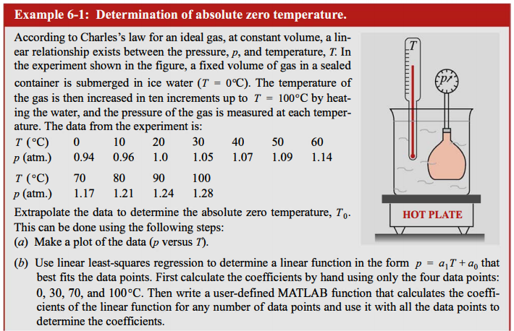

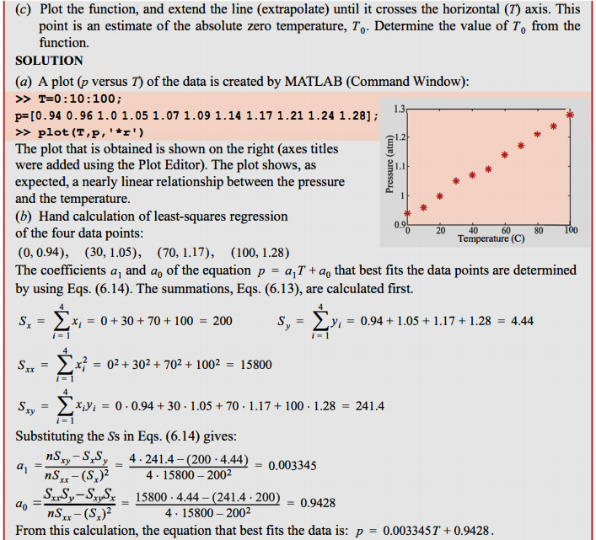

### Curve-Fitting with a Nonlinear Equation by Rewriting in Linear Form

Many times the relationships between quantities is nonlinear.

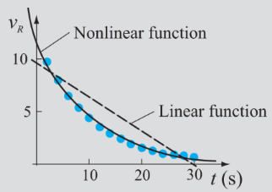

It is clear that a nonlinear function will give a better fit than a linear function.

To write nonlinear equations in linear form, we take for example the power function:

$y=bx^{m}$

Then:

$ln(y)=ln(bx^{m})=m ln(x)+ln(b)$*(Using $y=a_{1}x+a_{0}$)*

This equation is linear for $ln(y)$ in terms of $ln(x)$. Using linear least-squares regression we can determine:

$a_{1}=m, a_{2}=ln(b)$

$⇒m=a_{1}, b=e^{(a_{0})}$

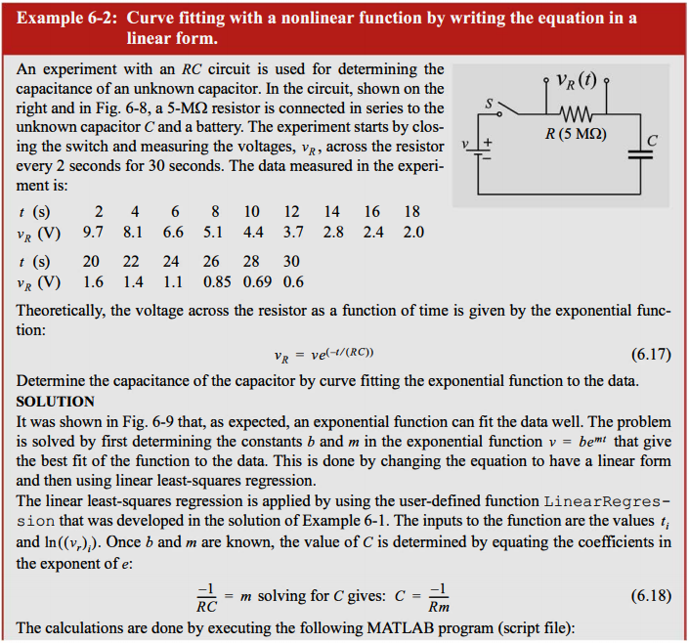

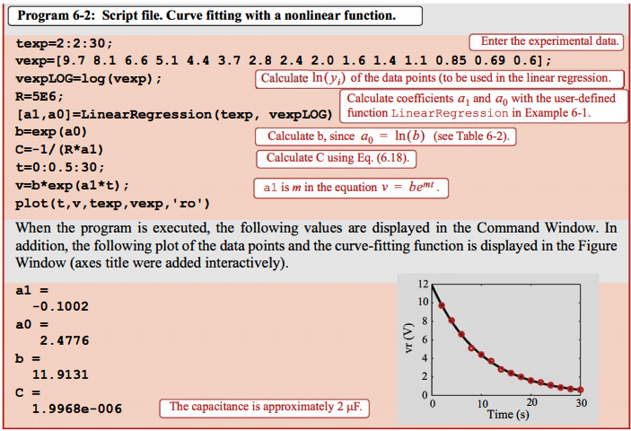

Choosing the appropriate nonlinear function to fit the data is often guided by a prior knowledge of what it is likely to be a best fit.

In the following example, we could plot $v_{R}$ vs. time $t$ with a logarithmic scale, or we could plot ${ln(v}_{R})$ vs. time $t$ to get a good straight line.

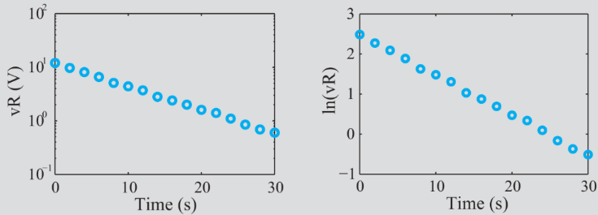

Other considerations when choosing a nonlinear function:

1. Exponential functions **cannot pass through the origin**.
2. Exponential functions can only fit data with all $+ve$ or $-ve$ $y$ s.
3. Logarithmic functions cannot include $x=0$ or $x$ $-ve$.
4. For the **power function $y=0$**  when $x=0$.
5. The **reciprocal equation cannot include $y=0$** .

# Curve-Fitting with Quadratic and Higher-Order Polynomials

Polynomials are functions of the form:

$f(x)=a_{n}x^{n}+a_{n-1}x^{n-1}+...+a_{1}x+a_{0}$

A given set of $n$ data points can be curve fit with polynomials up to the order $n-1$.

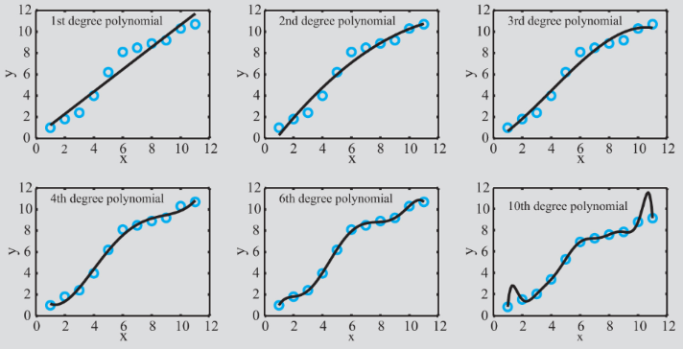

The higher the order of the polynomial chosen, the more data points it will pass through.

It is important to note that higher-order polynomials may pass through more points, but **may deviate significantly** from the overall trend thus making the approximate governing equation **inaccurate**.

### Polynomial Regression

This is a procedure for determining the coefficients of a polynomial of second degree or higher, that best fits the data points.

The procedure is based on the same approach taken by linear regression (finding a polynomial of order 1 - a line) to fit the data. The goal is again to **minimise the overall error** in a **least squares** sense.

If the polynomial that is used for curve fitting is:

$f(x)=a_{n}x^{n}+a_{n-1}x^{n-1}+...+a_{1}x+a_{0}$

For a given set of $n$ data points $(x_{i}, y_{i})$ the total error is:

$E=\sum_{i=1}^{n}{}{\left[y_{i}-(a_{m}x_{i}^{m}+a_{m-1}x_{i}^{m-1}+...+a_{1}x_{i}+a_{0})\right]}^{2}$

where $m≤n-1$

Taking for example $m=2$ (a quadratic polynomial) we have:

$E=\sum_{i=1}^{n}{}{\left[y_{i}-(a_{2}x_{i}^{2}+a_{1}x_{i}+a_{0})\right]}^{2}$

For a minimum error, the partial derivatives must be zero:

$\frac{∂E}{∂a_{0}}=-2\sum_{i=1}^{n}{}{(y}_{i}-a_{2}x_{i}^{2}+-x_{i}-a_{0})=0$

$\frac{∂E}{∂a_{1}}=-2\sum_{i=1}^{n}{}{(y}_{i}-a_{2}x_{i}^{2}+-x_{i}-a_{0}){ x}_{i}=0$

$\frac{∂E}{∂a_{2}}=-2\sum_{i=1}^{n}{}{(y}_{i}-a_{2}x_{i}^{2}+-x_{i}-a_{0}){ x}_{i}^{2}=0$

This system of linear equations in terms of the unknowns $a_{0}$, $a_{1}$ and $a_{2}$ can be rewritten:

$na_{0}+(\sum_{i=1}^{n}{}x_{i})a_{1}+(\sum_{i=1}^{n}{}x_{i}^{2})a_{2}=\sum_{i=1}^{n}{}y_{i}$

$(\sum_{i=1}^{n}{}x_{i})a_{0}+(\sum_{i=1}^{n}{}x_{i}^{2})a_{1}+(\sum_{i=1}^{n}{}x_{i}^{3})a_{2}=\sum_{i=1}^{n}{}x_{i} y_{i}$

$(\sum_{i=1}^{n}{}x_{i}^{2})a_{0}+(\sum_{i=1}^{n}{}x_{i}^{3})a_{1}+(\sum_{i=1}^{n}{}x_{i}^{4})a_{2}=\sum_{i=1}^{n}{}x_{i}^{2} y_{i}$

The solution to this system of equations gives the values of the coefficients $a_{0}$, $a_{1}$ and $a_{2}$ of the polynomial $y=a_{2}x_{i}^{2}+a_{1}x_{i}+a_{0}$ that best fits the $n$ data points $(x_{i}, y_{i})$.

The coefficients for higher-order polynomials is derived in the same way.

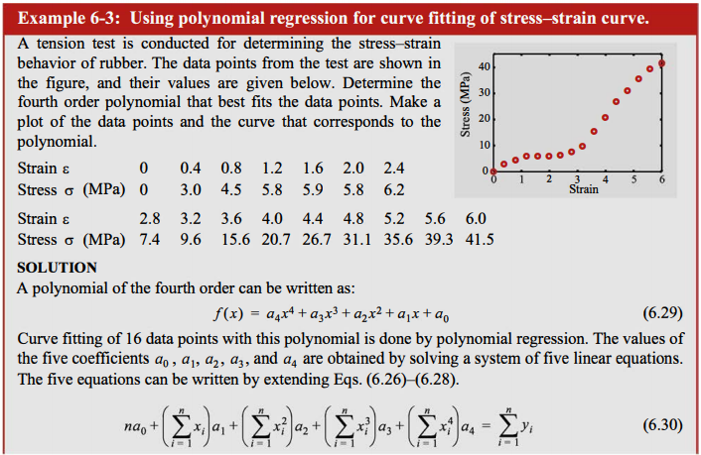

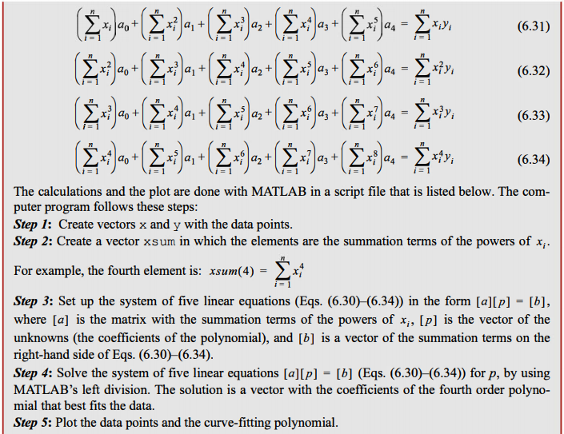

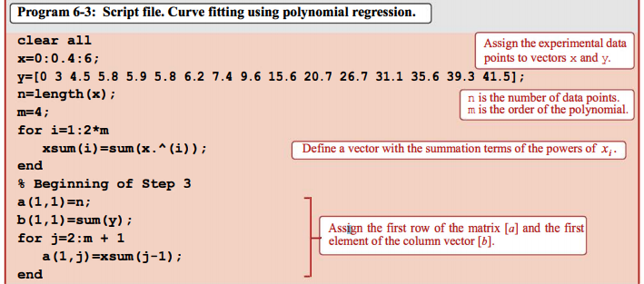

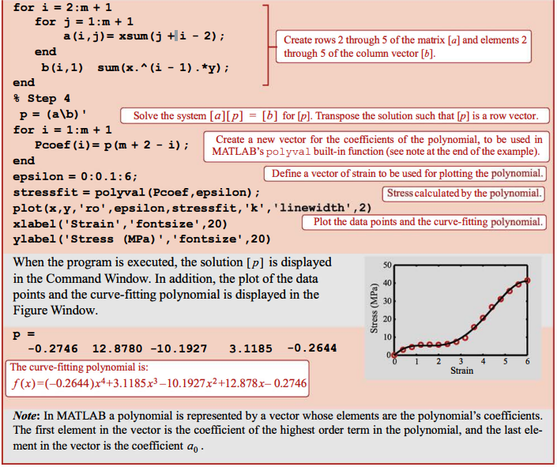

# Curve-Fitting with a Linear Combination of Nonlinear Functions

To generalise, least squares regression for any type (or types) of function (e.g. the exponential function) we write:

$F(x)=C_{1} f_{1}(x)+C_{2} f_{2}(x)+...+C_{m} f_{m}(x)=\sum_{j=1}^{m}{}C_{j} f_{j}(x_{i})$**(6.91)**

where $f_{1},{ f}_{2}, ..., f_{n}$ are predescribed functions, and $C_{1},{ C}_{2}, ..., C_{n}$ are unknown coefficients.

Using **least squares regression**, equation (6.91) is used to fit a given set of $n$ points $(x_{1},y_{1}), ..., (x_{n},y_{n})$ by **minimising the total error** that is given by the **sum of squares** of the **residuals**:

$E=\sum_{i=1}^{n}{}{\left[y_{i}-\sum_{j=1}^{m}{}C_{j}{ f}_{j}(x_{i})\right]}^{2}$**(6.92)**

Minimising $E$ gives:

$\frac{∂E}{∂C_{k}}=0$ $for k=1,2,...,m$**(6.93)**

Substituting equation (6.92) into (6.93) gives:

$\frac{∂E}{∂C_{k}}=\sum_{i=1}^{n}{}2\left[y_{i}-\sum_{j=1}^{m}{}C_{j}{ f}_{j}(x_{i})\right]\left[-\frac{∂}{∂C_{k}}\left(\sum_{j=1}^{m}{}C_{j}{ f}_{j}(x_{i})\right)\right]=0$ $for k=1,2,...,m$**(6.94)**

Now define:

$\frac{∂}{∂C_{k}}\left(\sum_{j=1}^{m}{}C_{j}{ f}_{j}(x_{i})\right)={ f}_{k}(x_{i})$

Equation (6.94) becomes:

$\frac{∂E}{∂C_{k}}=\sum_{i=1}^{n}{}-2\left[y_{i}-\sum_{j=1}^{m}{}C_{j}{ f}_{j}(x_{i})\right]{ f}_{k}(x_{i})=0$

This can be rewritten:

$\sum_{i=1}^{n}{}\sum_{j=1}^{m}{}C_{j}{ f}_{j}(x_{i}){ f}_{k}(x_{i})=\sum_{i=1}^{n}{}y_{i} f_{k}(x_{i})$ $for k=1,2,...,m$**(6.97)**

This latter equation is a system of $m$ linear equations in $m$ unknowns ($C_{k}$) and so equation (6.91) can be satisfied.

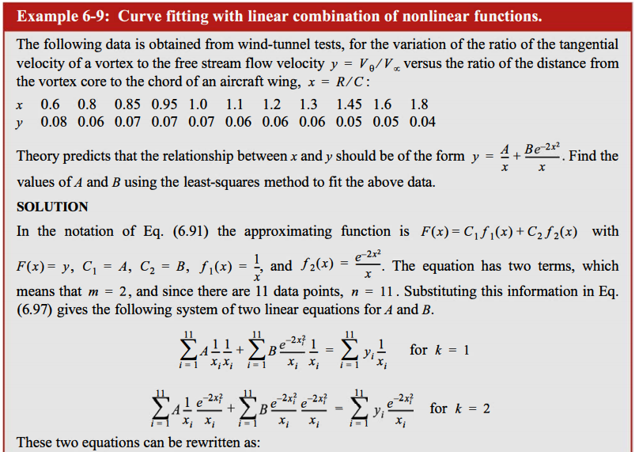

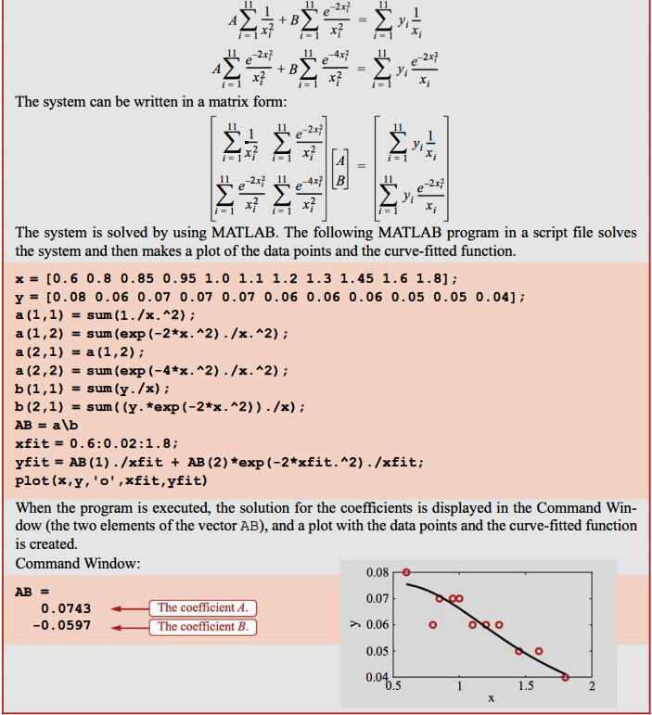

# Interpolation Using a Single Polynomial

Interpolation is a procedure in which a mathematical formula is used to represent a given set of data points, such that the formula gives the **exact value at the data points** and an **estimated value between the points**.

For any $n$ points, there is a unique polynomial of order $n-1$ that passes through **all** the points.

For two points the order of the polynomial is 1 - giving us a line.

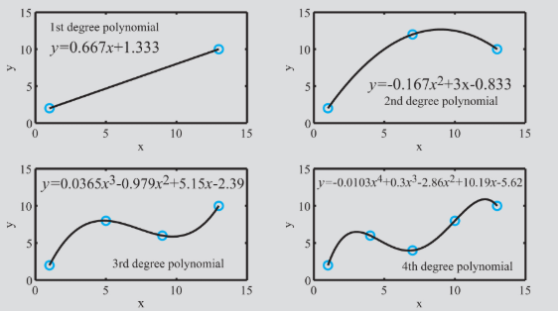

The polynomial can be written in three forms:

1. Standard
2. Lagrange
3. Newton’s

### Standard Form

The standard form of an th order polynomial is:

$f(x)=a_{n}x^{n}+a_{n-1}x^{n-1}+...+a_{1}x+a_{0}$

The equations are written explicitly for each data point by substituting the value of each data point in turn into the polynomial. This results in a **system of linear equations** in terms of the polynomial coefficients to be determined.

**Example**:

We have five points, so we need to use a 4th order polynomial to guarantee that it passes through all data points.

The data is: $(1,2), (4,6), (7,4), (10,8), (13,10)$

|  |
| --- |
| $a_{4}{(1)}^{4}+a_{3}{(1)}^{3}+a_{2}{(1)}^{2}+a_{1}(1)+a_{0}=2$ $a_{4}{(4)}^{4}+a_{3}{(4)}^{3}+a_{2}{(4)}^{2}+a_{1}(4)+a_{0}=6$ $a_{4}{(7)}^{4}+a_{3}{(7)}^{3}+a_{2}{(7)}^{2}+a_{1}(7)+a_{0}=4$ $a_{4}{(10)}^{4}+a_{3}{(10)}^{3}+a_{2}{(10)}^{2}+a_{1}(10)+a_{0}=8$ $a_{4}{(13)}^{4}+a_{3}{(13)}^{3}+a_{2}{(13)}^{2}+a_{1}(13)+a_{0}=10$ |

This system of equations can be solved for the coefficients of the polynomial using any of the methods described previously. However, this process is not efficient and the coefficients matrix can be ill-conditioned.

Hence, we look further to polynomial representation in Lagrange and Newton’s forms.

### Lagrange Interpolating Polynomials

The coefficients of these polynomials can be carried out readily by hand or with a computer.

For a line the first order Lagrange polynomial that passes through the two points has the form:

$f(x)=y=a_{1}(x-x_{2})+a_{2}(x-x_{1})$**(6.37)**

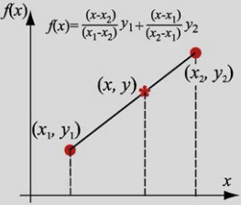

This can be shown to be the standard definition for a line passing through two known points.

Substituting two known points into the above equation gives:

$y_{1}=a_{1}(x_{1}-x_{2})+a_{2}(x_{1}-x_{1})$ or $a_{1}=\frac{y_{1}}{(x_{1}-x_{2})}$

$y_{2}=a_{1}(x_{2}-x_{2})+a_{2}(x_{2}-x_{1})$ or $a_{2}=\frac{y_{2}}{(x_{2}-x_{1})}$

Substituting the coefficients back into equation (6.37) gives:

$f(x)=\frac{(x-x_{2})}{(x_{1}-x_{2})}y_{1}+\frac{(x-x_{1})}{(x_{2}-x_{1})}y_{2}$**(6.40)**

or

$f(x)=\frac{(y_{2}-y_{1})}{(x_{2}-x_{1})}x+\frac{x_{2}y_{1}-x_{1}y_{2}}{(x_{2}-x_{1})}$**(6.41)**

which is a familiar equation for a line through two known points $(x_{1},y_{1})$ and $(x_{2},y_{2})$.

Note that if $x=x_{1}$ is substituted into equation (6.40) or (6.41), then the value of the polynomial is $y_{1}$. Ditto for $x=x_{2}$.

#### Second Order Lagrange Polynomials

For **three points**, a second order Lagrange polynomial is used:

$f(x)=y=a_{1}(x-x_{2})(x-x_{3})+a_{2}(x-x_{1})(x-x_{3})+a_{3}(x-x_{1})(x-x_{2})$

Once the coefficients are determined such that the polynomial passes through the three data points, the polynomial becomes a **quadratic function** of $x$ as given in equation (6.43).

$f(x)=\frac{(x-x_{2})(x-x_{3})}{(x_{1}-x_{2})(x_{1}-x_{3})}y_{1}+\frac{(x-x_{1})(x-x_{3})}{(x_{2}-x_{1})(x_{2}-x_{3})}y_{2}+\frac{(x-x_{1})(x-x_{2})}{(x_{3}-x_{1})(x_{3}-x_{2})}y_{3}$**(6.43)**

Note that when we substitute $x_{1}$, then $f(x)=y_{1}$.

This is because the coefficient corresponding to $y_{1}$ is $1$ and all other coefficients are zero.

This is characteristic of **all Lagrange polynomials**.

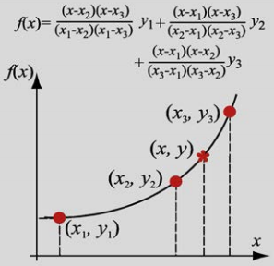

#### General Form

The general form of a Lagrange polynomial that passes through $n$ points is:

$f(x)=\frac{(x-x_{2})(x-x_{3})...(x-x_{n})}{(x_{1}-x_{2})(x_{1}-x_{3})...(x_{1}-x_{n})}y_{1}+\frac{(x-x_{1})(x-x_{3})...(x-x_{n})}{(x_{2}-x_{1})(x_{2}-x_{3})...(x_{2}-x_{n})}y_{2}+\frac{(x-x_{1})(x-x_{2})...(x-x_{n})}{(x_{i}-x_{1})(x_{i}-x_{2})...(x_{i}-x_{n})}y_{i}+...+\frac{(x-x_{1})(x-x_{2})...(x-x_{n-1})}{(x_{n}-x_{2})(x_{n}-x_{2})...(x_{n}-x_{n-1})}y_{n}$

or

$f(x)=\sum_{i=1}^{n}{}y_{i}L_{i}(x)=\sum_{i=1}^{n}{}y_{i}\prod_{j=1, j≠i}^{n}{}\frac{(x-x_{j})}{(x_{i}-x_{j})}$

where $L_{i}(x)=\prod_{j=1, j≠i}^{n}{}\frac{(x-x_{j})}{(x_{i}-x_{j})}$ are known as **Lagrange functions**.

#### Notes on Lagrange Polynomials

* The **spacing** between data points does **not** have to be equal.
* For a given set of data points, the whole expression for the interpolation polynomial has to be calculated for each interpolation value of $x$.
* If a data point is added, then the whole expression for the polynomial has to be **calculated again**. This does not have to be done with Newton’s polynomials.

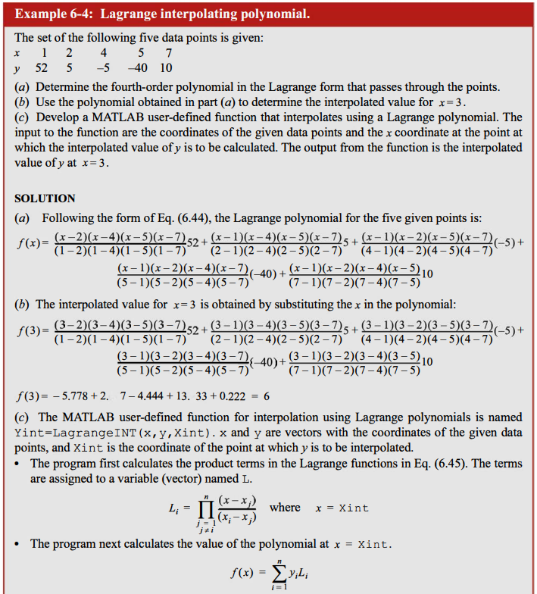

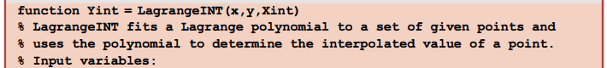

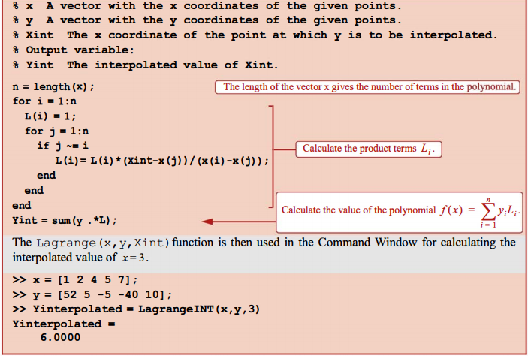

### Newton’s Interpolating Polynomials

The general form of an $n-1$ order Newton’s polynomial that passes through $n$ points is:

$f(x)=a_{1}+a_{2}(x-x_{1})+a_{3}(x-x_{1})(x-x_{2})+...+a_{n}(x-x_{1})(x-x_{2})...(x-x_{n-1})$

The coefficients $a_{i}$ are easily calculated. The major advantage of Newton’s polynomials is that if a data point is added, then the **previous coefficients remain the same** and only the new coefficient needs to be calculated so that the resulting polynomial passes through all points.

#### First Order Newton’s Polynomial

For two data points $(x_{1},y_{1})$ and $(x_{2},y_{2})$, the first order Newton’s polynomial has the form: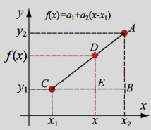

$f(x)=a_{1}+a_{2}(x-x_{1})$

The coefficients can be calculated by evaluating the polynomial for $(x_{1},y_{1})$ and $(x_{2},y_{2})$ giving:

$y_{1}=a_{1}+a_{2}(x_{1}-x_{1})⇒a_{1}=y_{1}$

and

$y_{2}=a_{1}+a_{2}(x_{2}-x_{1})⇒a_{2}=\frac{y_{2}-y_{1}}{x_{2}-x_{1}}$*(substituting $a_{1}=y_{1}$)*

#### Second Order Newton’s Polynomial

For three data points $(x_{1},y_{1})$ and $(x_{2},y_{2})$, the second order Newton’s polynomial has the form: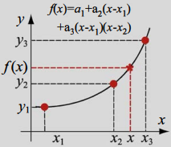

$f(x)=a_{1}+a_{2}(x-x_{1})+a_{3}(x-x_{1})(x-x_{2})$

Substituting $(x_{1},y_{1})$ gives $a_{1}=y_{1}$ as before.

Substituting $(x_{2},y_{2})$ gives $a_{2}=\frac{y_{2}-y_{1}}{x_{2}-x_{1}}$ as before.

Substituting $(x_{3},y_{3})$ gives:

$a_{3}=\frac{\frac{y_{3}-y_{2}}{x_{3}-x_{2}}-\frac{y_{2}-y_{1}}{x_{2}-x_{1}}}{x_{3}-x_{1}}$

#### Third Order Newton’s Polynomial

$f(x)=a_{1}+a_{2}(x-x_{1})+a_{3}(x-x_{1})(x-x_{2})+a_{4}(x-x_{1})(x-x_{2})(x-x_{3})$

$a_{1}$, $a_{2}$ and $a_{3}$ are the same as for Newton’s second polynomial, and:

$a_{4}=\frac{\frac{(\frac{y_{4}-y_{3}}{x_{4}-x_{3}}-\frac{y_{3}-y_{2}}{x_{3}-x_{2}})}{x_{4}-x_{2}}-\frac{(\frac{y_{3}-y_{2}}{x_{3}-x_{2}}-\frac{y_{2}-y_{1}}{x_{2}-x_{1}})}{x_{3}-x_{1}}}{x_{4}-x_{1}}$

#### General Form for Newton’s Polynomial and Coefficients

For two points (a line):

$a_{1}=y_{1}$

$f\left[x_{2},x_{1}\right]=\frac{y_{2}-y_{1}}{x_{2}-x_{1}}=a_{2}$

where $f\left[x_{2},x_{1}\right]$ is known as the **first divided difference**.

For three points ($a_{1}$ and $a_{2}$ as before):

$f\left[x_{3},x_{2},x_{1}\right]=\frac{f\left[x_{3},x_{2}\right]-f\left[x_{2},x_{1}\right]}{x_{3}-x_{1}}=\frac{\frac{y_{3}-y_{2}}{x_{3}-x_{2}}-\frac{y_{2}-y_{1}}{x_{2}-x_{1}}}{x_{3}-x_{1}}=a_{3}$

For four points ($a_{1}$, $a_{2}$ and $a_{3}$ as before):

$f\left[x_{4},x_{3},x_{2},x_{1}\right]=\frac{f\left[x_{4},{x_{3},x}_{2}\right]-f\left[{x_{3},x}_{2},x_{1}\right]}{x_{4}-x_{1}}=\frac{\frac{f\left[x_{4},x_{3}\right]-f\left[x_{3},x_{2}\right]}{x_{4}-x_{2}}-\frac{f\left[x_{3},x_{2}\right]-f\left[x_{2},x_{1}\right]}{x_{3}-x_{1}}}{x_{3}-x_{1}}=...=a_{4}$

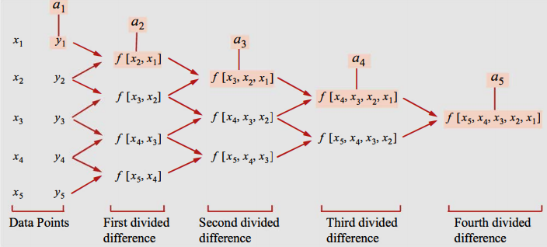

In general, the th divided difference for second and higher divided differences up to the th divided difference is:

$f\left[x_{k},x_{k-1},...,x_{2},x_{1}\right]=\frac{f\left[x_{k},x_{k-1},...,x_{3},x_{2}\right]-f\left[x_{k-1},x_{k-2},...,x_{2},x_{1}\right]}{x_{k}-x_{1}}$

With these definitions, the th polynomial is:

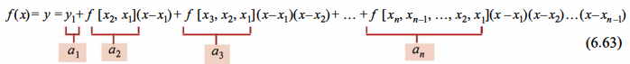

#### Notes on Newton Polynomials

* The spacing between the data points does not have to be the same.
* Data points can be subsequently added and only one coefficient per extra data point needs to be calculated.
* The data points do not have to be in any particular order.

For these reasons, Newton’s polynomials are a popular choice.

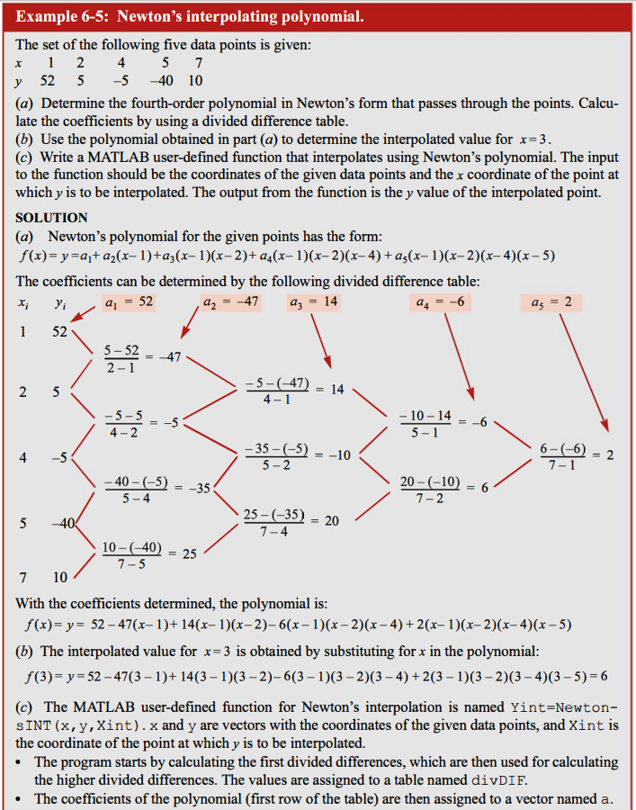

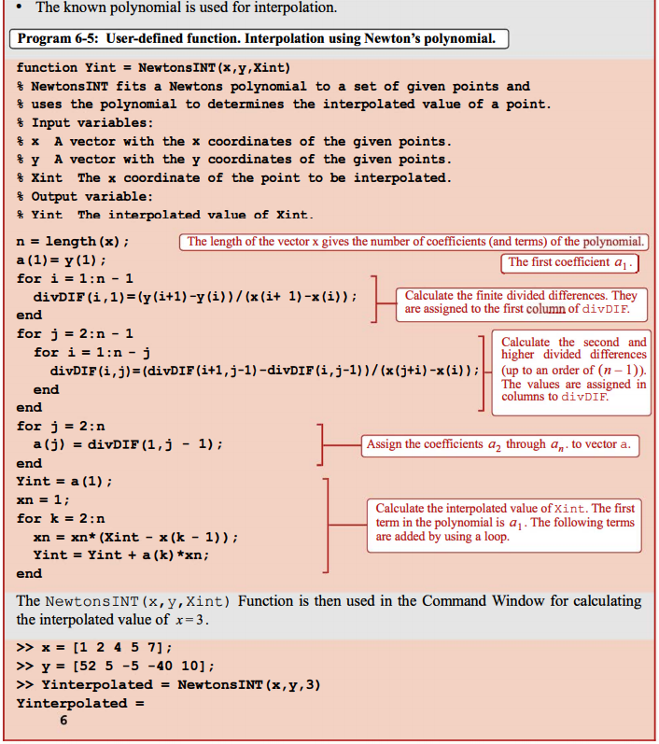

### Piecewise (Spinewise) Interpolation

When there are a large number of data points, a single-order polynomial interpolation may result in large deviations from the general trend.

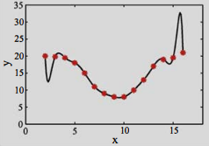

To circumvent this problem, it is possible to use **lower-order polynomials** in a piecewise manner to interpolate. This form of interpolation is called **piecewise** or **spline interpolation**, and the data points where the polynomials from **two adjacent intervals meet** are called **knots**.

#### Linear Splines

Interpolation is carried out using first-order polynomials (linear functions) between the points. In other words, the data points are connected by straight lines.

Using **Lagrange form**, the equation of the straight line that connects two points is given by:

$f(x)=\frac{(x-x_{2})}{(x_{1}-x_{2})}y_{1}+\frac{(x-x_{1})}{(x_{2}-x_{1})}y_{2}$

Generalising for successive data points $(x_{1},y_{1})$ and $(x_{2},y_{2})$ gives:

$f_{i}(x)=\frac{(x-x_{i+1})}{(x_{i}-x_{i+1})}y_{i}+\frac{(x-x_{i})}{(x_{i+1}-x_{i})}y_{i+1}$ $for i=1,2,...,n-1$

Interpolation with linear splines is easy to do and gives good results when the data points are **closely-spaced**.

For widely-spaced points, it becomes less accurate because of the large changes in slope of the lines connecting the data points. In this case it is preferable to use higher-order polynomials.

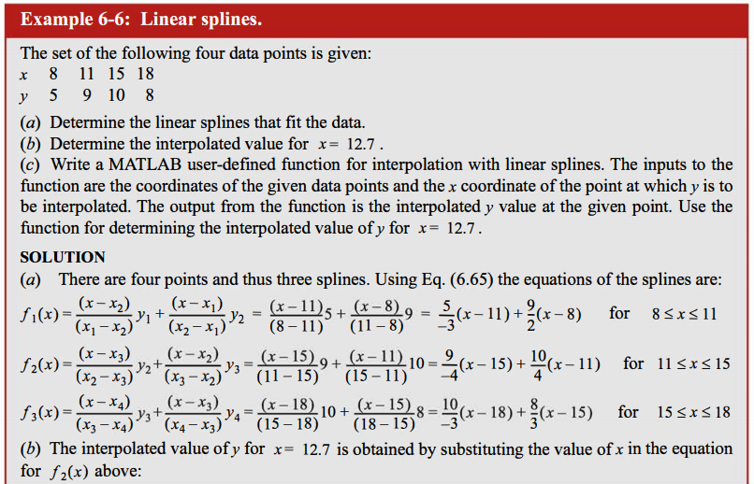

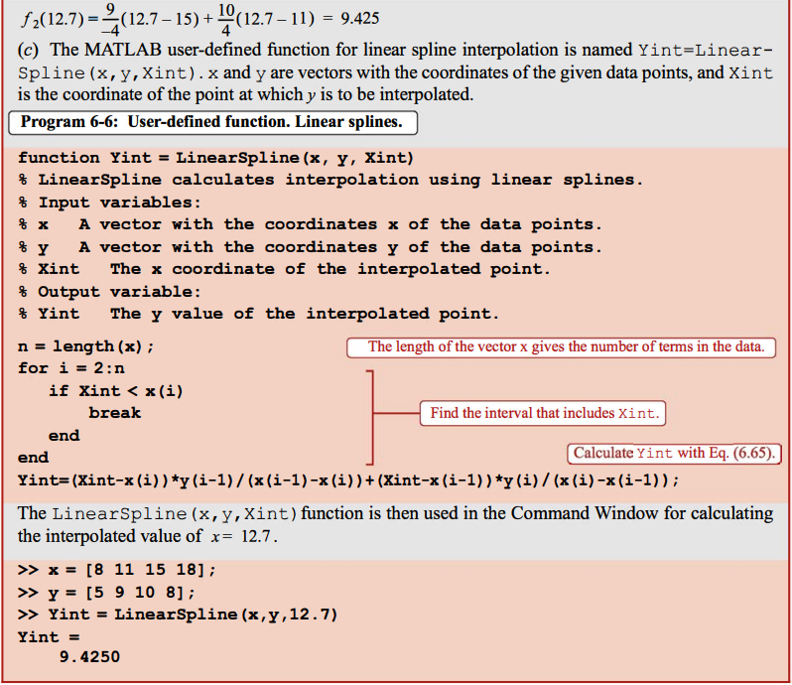

#### Quadratic Splines

Here, **second-order polynomials** are used for interpolation. The polynomial in the th interval between points $(x_{i},y_{i})$ and $(x_{i+1},y_{i+1})$ is:

$f_{i}(x)=a_{i}x^{2}+b_{i}x+c_{i}$ $for i=1,2,...,n-1$

For $n$ data points there are $n-1$ intervals and consequently $n-1$ polynomials. Each polynomial has three coefficients, so a total of $3(n-1)$ coefficients have to be determined.

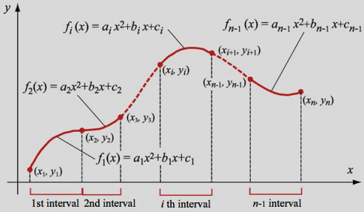

The coefficients are determined by applying the following conditions:

1. Each polynomial $f_{i}(x)$**must pass through the endpoints of the interval $(x_{i},y_{i})$**  and $(x_{i+1},y_{i+1})$. $a_{i}x_{i}^{2}+b_{i}x_{i}+c_{i}=y_{i}$ $for i=1,2,...,n-1$ $a_{i}x_{i+1}^{2}+b_{i}x_{i+1}+c_{i}=y_{i+1}$ $for i=1,2,...,n-1$
     
      
      
     
   Since there are $n-1$ intervals, these conditions give $2(n-1)$ equations.
2. At the interior points (knots) (there are $n-2$ of them), the **slopes** (first derivative) **from adjacent intervals are equal**.  
     
   In general, the first derivative of the th polynomial is:  
     
     
   Equating the successive first derivatives at all of the interior points gives: $2a_{i-1}x+b_{i-1}=2a_{i}x+b_{i}$ $for i=2,3,...,n-1$
      
     
   Since there are $n-2$ interior points, this gives us $n-2$ equations.

From *1.* and *2.* we now have $2(n-1)+(n-2)=3n-4$ equations.

However, the $n-1$ polynomials have $n-3$ coefficients, so we need one more condition so that we can solve for the coefficients.

1. We apply the condition that the second derivative at the first point is zero.  
   The polynomial in the first interval is: $f_{1}(x)=a_{1}x^{2}+b_{1}x+c_{1}$ 
     
   Hence $f_{1}''(x)={2a}_{1}$  
     
   Equating this to zero gives $a_{1}=0$ which means that a **straight line** connects the first two points.

We now have $3n-3$ equations (in terms of the coefficients) that allow us to solve for all coefficients.

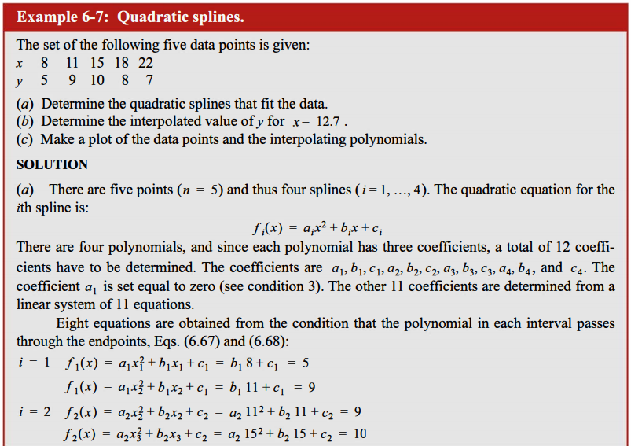

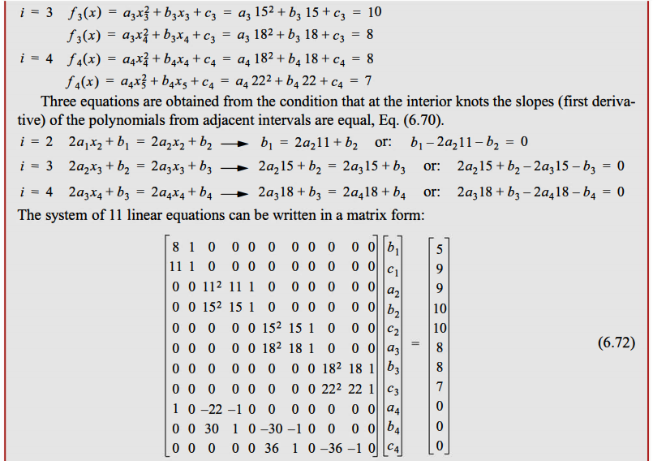

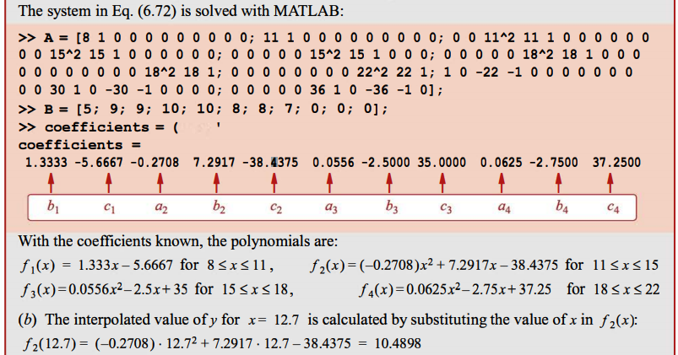

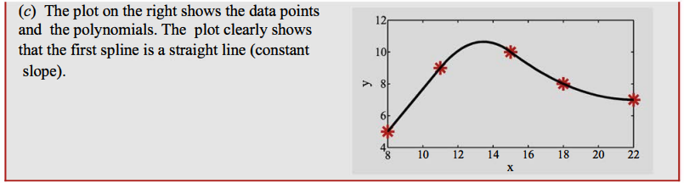

#### Cubic Splines

The equation of the polynomial in the th interval between points $x_{i}$ and $x_{i+1}$ is:

$f_{i}(x)=a_{i}x^{3}+b_{i}x^{2}+c_{i}x+d_{i}$

Overall, there are $n-1$ such equations (corresponding to $n-1$) intervals.

Since each equation has four coefficients, we need $4(n-1)$ equations (in terms of coefficients) in order to solve for these.

Like with the use of quadratic equations, we impose $4(n-1)$ conditions on the equations.

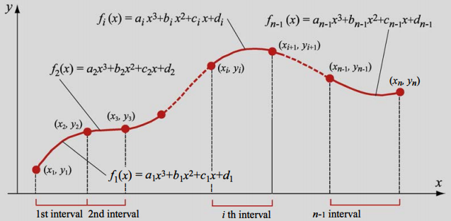

Conditions:

1. Each polynomial $f_{i}(x)$**must pass through the endpoints of the interval $(x_{i},y_{i})$**  and $(x_{i+1},y_{i+1})$ $a_{i}x_{i}^{3}+b_{i}x_{i}^{2}+c_{i}x_{i}+d_{i}=y_{i}$ $for i=1,2,...,n-1$ $a_{i}x_{i+1}^{3}+b_{i}x_{i+1}^{2}+c_{i}x_{i+1}+d_{i}=y_{i}$ $for i=1,2,...,n-1$
     
      
      
     
   Since there are $n-1$ intervals, these conditions give $2(n-1)$ equations.
2. At the interior knots (there are $n-2$ of them), the **slopes** (first derivative) **from adjacent intervals are equal**.  
     
   In general, the first derivative of the th polynomial is:  
     
     
   Equating the successive first derivatives at all of the interior points gives: $3a_{i-1}x_{i}^{2}+2b_{i-1}x_{i}+c_{i}=3a_{i}x_{i}^{2}+2b_{i}x_{i}+c_{i}$ $for i=2,3,...,n-1$
      
     
   Since there are $n-2$ interior points, this gives us $n-2$ equations.
3. At the interior points (knots), the **second derivatives** of the polynomials **from adjacent intervals are equal**. The rate of change of the slopes must be equal.  
     
   The second derivative of the polynomial in the th interval is: $f''(x)=\frac{d^{2}f}{dx^{2}}=6a_{i}x+2b_{i}$ 
     
     
   Equating the successive first derivatives at all of the interior points gives: $6a_{i}x_{i-1}+2b_{i-1}=6a_{i}x_{i}+2b_{i}$ $for i=2,3,...,n-1$
      
     
   Since there are $n-2$ interior points, this gives us $n-2$ equations.
4. Lastly, we enforce the condition that the **second derivatives** at the **first** and **last points** equal zero. This gives the two remaining equations that we need to solve for all coefficients. $6a_{1}x_{1}+2b_{1}=6a_{n-1}x_{n}+2b_{n-1}$

Cubic splines whose second derivatives are equal to zero at the end points are called **natural cubic splines**.

#### Cubic Splines based on Lagrange Form Polynomials

The derivation of cubic splines using the Lagrange form starts with the **second derivative** of the polynomial. The second derivative of a cubic polynomial is a **linear function**.

For the th interval, this function can be written in the Lagrange form:

$f_{i}''(x)=\frac{x-x_{i+1}}{x_{i}-x_{i+1}} f_{i}''(x_{i})+\frac{x-x_{i}}{x_{i+1}-x_{i}}f_{i}''(x_{i+1})$

Hence, the third-order polynomial in the th interval can be obtained by integrating the above equation twice. This results in **two constants of integration** which can be obtained from the condition that the values of the polynomial at the knot are known:

$f_{i}(x_{i})=y_{i}$ and $f_{i}(x_{i+1})=y_{i+1}$

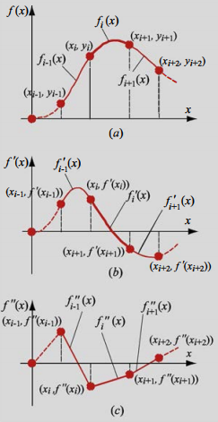

Once the constants of integration are determined, the third order polynomial in the th interval is:

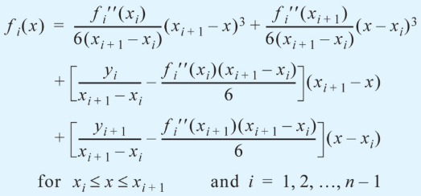 **(6.82)**

We obtain $n-2$**linear equations** by enforcing continuity of the first derivatives at the interior points:

$f_{i}'(x_{i+1})=f_{i+1}'(x_{i+1})$ $for i=1,2,...,n-2$**(6.83)**

This condition is applied by differentiating equation (6.82), and substituting these derivatives into equation (6.83) giving the interpolating polynomial for each interval:

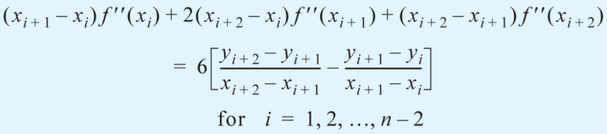 **(6.84)**

This is a system of $n-2$ equations with $n$ unknowns ( $f_{i}''(x_{i})$ and $f_{i+1}''(x_{i+1})$).

As before we enforce the condition that the second derivatives at the endpoints are equal to zero.

$f''(x_{1})=0$ and $f''(x_{n})=0$**(6.85)**

Between equations (6.84) and (6.85) we now have the $2(n-1)$ equations needed to express equation (6.82).

The process of solving for $f_{i}''(x_{i})$ and $f_{i+1}''(x_{i+1})$ can be **simplified** by defining:

1. $h_{i}$ as the **length** of the th interval
2. $a_{i}$ as the **second derivative** of the polynomial at the point $x_{i}$

$h_{i}=x_{i+1}-x_{i}$

$a_{i}=f''(x_{i})$

With these definitions, the equation of the polynomial in the th interval is:

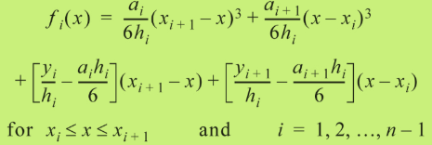

and the system of linear equations that have to be solved for the $a_{i}$ s is:

$h_{i}a_{i}+2(h_{i}+h_{i+1})a_{i+1}+h_{i+1}a_{i+2}=6\left[\frac{y_{i+2}-y_{i+1}}{h_{i+1}}-\frac{y_{i+1}-y_{i}}{h_{i}}\right]$ $for i=1,2,...,n-2$

$a_{i}$ and $a_{n}$ are zero - natural splines.

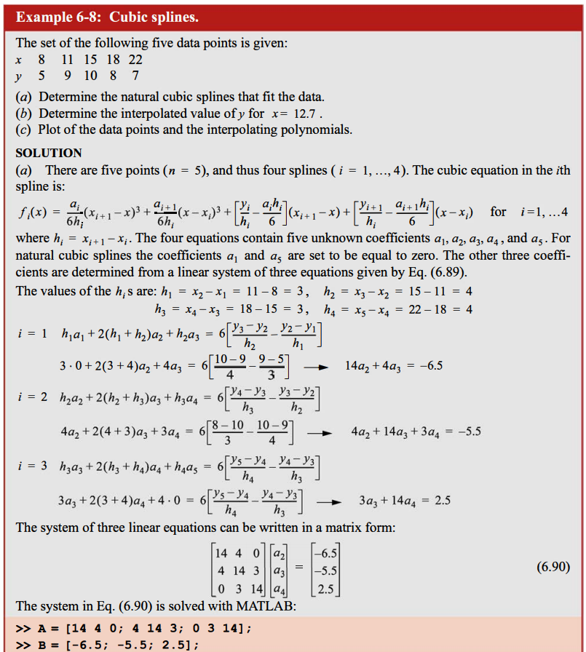

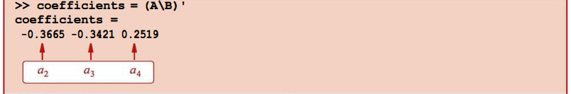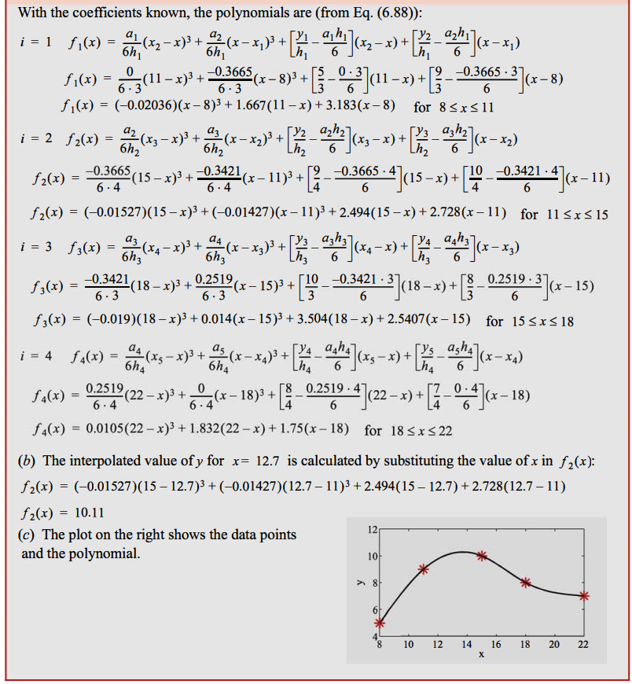

08 Numerical Differentiation

Numerical differentiation is needed where the function in question cannot be differentiated analytically, cannot be differentiated easily and / or there are many differentiations to be performed.

The simplest approach is to use the **finite difference approximation** for the derivative.

This approach calculates the derivative $f'(x_{i})$ by obtaining the slope of the line containing $f'(x_{i-1})$ and $f'(x_{i+1})$ which are experimental data points or values of a discretised continuous function.

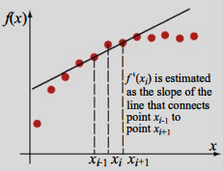

Another approach is to obtain an analytic expression for $f(x)$ by **curve-fitting** and differentiating the resulting analytic expression.

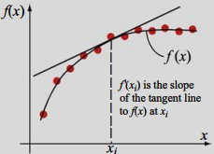

Oftentimes there is a lot of scatter in experimental data which means that there can be large inaccuracies in differentiation using the finite difference method. This can be remedied using **higher-order** finite difference approximations.

# Finite Difference Approximation of the Derivative

The derivative $f'(x)$ of a function $f(x)$ at the point $x=a$ is defined by: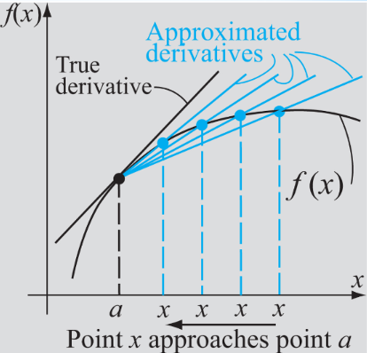

$\frac{df(x)}{dx}│_{x=a}=f'(a)=\lim_{x→a}\frac{f(x)-f(a)}{x-a}$

This is the slope of the tangent to the function $f(x)$ at the point $x=a$.

The derivative is obtained by choosing a point $x$ close to $a$ and calculating the slope of the line containing these two points.

The closer $x$ is to $a$ the more accurate the result.

In finite difference approximations of the derivative, values of the function at different points in the neighbourhood of $x=a$ are used for estimating the slope.

Three such fundamental variants exist:

1. The **forward-difference** formula: $\frac{df}{dx}│_{x=x_{i}}=\frac{f(x_{i+1})-f(x_{i})}{x_{i+1}-x_{i}}$
2. The **backward-difference** formula: $\frac{df}{dx}│_{x=x_{i}}=\frac{f(x_{i})-f(x_{i-1})}{x_{i}-x_{i-1}}$
3. The **central-difference** formula: $\frac{df}{dx}│_{x=x_{i}}=\frac{f(x_{i+1})-f(x_{i-1})}{x_{i+1}-x_{i-1}}$

If the function is **slowly varying**, then the **central-difference formula** is usually the most accurate. That being said, all are accurate if the spacings between the points are made very small.

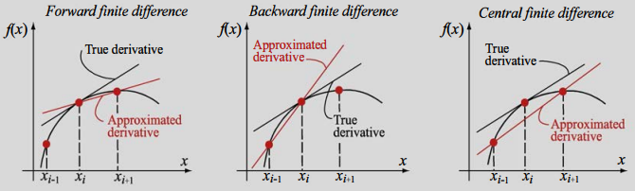

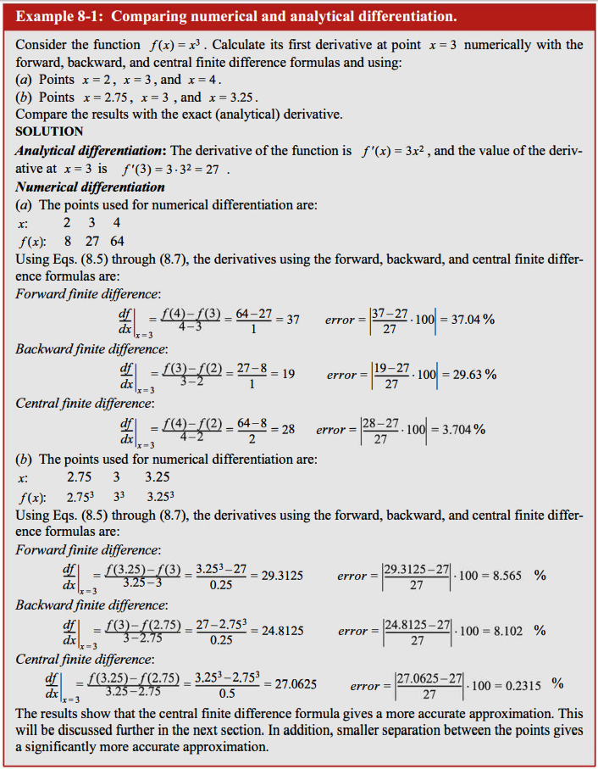

# Finite Difference Formulae using the Taylor Series Expansion

The forward, backward and central-difference formulae, as well as others, can be obtained using the Taylor series expansion of $f(x)$.

The advantage of using the Taylor series expansion is that an estimate of the error in the approximation can be obtained.

### The Two-Point Forward-Difference Formula

Assuming that points are evenly-spaced, we can write:

$O(h^{2})$

This can be written:

$f(x_{i+1})=f(x_{i})+f'(x_{i})h+\frac{f''(ζ)}{2!}h^{2}$

where $h=x_{i+1}-x_{i}$ and $ζ∈]x_{i},x_{i+1}[$

Solving for $f'(x_{i})$ yields:

$f'(x_{i})=\frac{f(x_{i+1})-f(x_{i})}{h}-\frac{f''(ζ)}{2!}h$

An approximate value of the derivative $f'(x_{i})$ can be calculated if the second term of the RHS is ignored. Ignoring this term introduces a truncation error which is said to be in the ‘order of $h$’, written $O(h)$, since it is proportional to $h$.

$TruncationError=\frac{f''(ζ)}{2!}h=O(h)$

Using this notation, we can write the forward-difference formula as:

$f'(x_{i})=\frac{f(x_{i+1})-f(x_{i})}{h}+O(h)$

### The Two-Point Backward-Difference Formula

Using Taylor’s theorem we can write:

$f(x_{i-1})=f(x_{i})-f'(x_{i})h+\frac{f''(x_{i})}{2!}h^{2}-\frac{f'''(x_{i})}{3!}h^{3}+...$

As before, this reduces to:

$f'(x_{i})=\frac{f(x_{i})-f(x_{i-1})}{h}+\frac{f''(ζ)}{2!}h$

This in turn gives:

$f'(x_{i})=\frac{f(x_{i})-f(x_{i-1})}{h}+O(h)$

### The Two-Point Central-Difference Formula

We write:

$f(x_{i+1})=f(x_{i})+f'(x_{i})h+\frac{f''(x_{i})}{2!}h^{2}+\frac{f'''(ζ_{1})}{3!}h^{3}$

and

$f(x_{i-1})=f(x_{i})+f'(x_{i})h+\frac{f''(x_{i})}{2!}h^{2}-\frac{f'''(ζ_{2})}{3!}h^{3}$

The spacings between points are equal ($h=x_{i+1}-x_{i}=x_{i}-x_{i-1}$).

Subtracting the latter from the former equation gives:

$f(x_{i+1})-f(x_{i-1})=2f'(x_{i})h+\frac{f'''(ζ_{1})}{3!}h^{3}+\frac{f'''(ζ_{2})}{3!}h^{3}$

Solving for $f'(x_{i})$ gives:

$f'(x_{i})=\frac{f(x_{i+1})-f(x_{i-1})}{2h}+O(h^{2})$

This gives us the noteworthy result that the central-difference formula is more accurate than the forward and backward-difference formula, because the order of the truncation error is $O(h^{2})$ rather than $O(h)$.

At the **endpoints** it is not possible to use the central difference formula for the derivative. Once can use the forward and backward-difference formulae, but the truncation error is larger.

It would therefore be useful if we could obtain a different formula for the endpoints, that has a smaller truncation error of $O(h^{2})$.

We derive the **three-point** forward and backward-difference formulae for the endpoints.

Letting the endpoint be $x_{i}$ then:

$f(x_{i+1})=f(x_{i})+f'(x_{i})h+\frac{f''(x_{i})}{2!}h^{2}+\frac{f'''(ζ_{1})}{3!}h^{3}$**(8.21)**

$f(x_{i+2})=f(x_{i})+f'(x_{i})2h+\frac{f''(x_{i})}{2!}{(2h)}^{2}+\frac{f'''(ζ_{2})}{3!}{(2h)}^{3}$**(8.22)**

where $ζ_{1}∈]x_{i},x_{i+1}[$ and $ζ_{2}∈]x_{i},x_{i+2}[$

Multiplying equation (8.21) by 4, and subtracting it from (8.22) gives:

$4f(x_{i+1})-f(x_{i+2})=3f(x_{i})+2f'(x_{i})h+\frac{4f'''(ζ_{1})}{3!}h^{3}-\frac{f'''(ζ_{2})}{3!}h^{3}$

Solving for $f'(x_{i})$ gives:

$f'(x_{i})=\frac{-3f(x_{i})+4f(x_{i+1})-f(x_{i+2})}{2h}+O(h^{2})$

This is our desired three-point forward-difference formula for use at one of the endpoints with a truncation error of $O(h^{2})$.

In likewise fashion, a three-point backward-difference formula can be derived for use at the other endpoint:

$f'(x_{i})=\frac{f(x_{i-2})-4f(x_{i-1})+3f(x_{i})}{2h}+O(h^{2})$

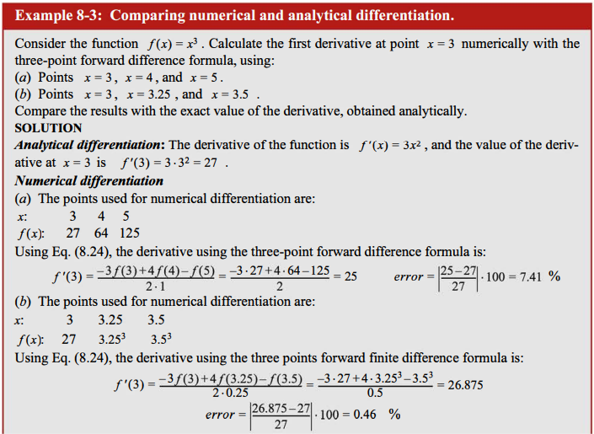

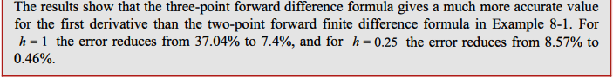

### The Three-Point Central-Difference Formula for the Second Derivative

We write:

$f(x_{i+1})=f(x_{i})+f'(x_{i})h+\frac{f''(x_{i})}{2!}h^{2}+\frac{f''(x_{i})}{3!}h^{3}+\frac{f^{(4)}(ζ_{1})}{4!}h^{4}$

and

$f(x_{i-1})=f(x_{i})-f'(x_{i})h+\frac{f''(x_{i})}{2!}h^{2}-\frac{f''(x_{i})}{3!}h^{3}+\frac{f^{(4)}(ζ_{2})}{4!}h^{4}$

where $ζ_{1}∈]x_{i},x_{i+1}[$ and $ζ_{2}∈]x_{i},x_{i+2}[$

Adding these equations gives:

$f(x_{i+1})+f(x_{i-1})=2f(x_{i})+2\frac{f''(x_{i})}{2!}h^{2}+\frac{f^{(4)}(ζ_{1})}{4!}h^{4}+\frac{f^{(4)}(ζ_{2})}{4!}h^{4}$

Solving for $f''(x_{i})$ gives:

$f''(x_{i})=\frac{f(x_{i-1})-2f(x_{i})+f(x_{i+1})}{h^{2}}+O(h^{2})$

This is a three-point central-difference formula that provides an estimate of the **second derivative** at the point $x_{i}$ in terms of the value of the function at that point $x_{i}$, the previous point $x_{i-1}$ and then next point $x_{i+1}$ with a truncation error of $O(h^{2})$.

The same procedure can be used to obtain higher-order formulae involving more points.

### The Three-Point Forward and Backward-Difference Formulae for the Second Derivative

$f(x_{i+1})=f(x_{i})+f'(x_{i})h+\frac{f''(x_{i})}{2!}h^{2}+\frac{f'''(ζ_{1})}{3!}h^{3}$**(8.21 again)**

$f(x_{i+2})=f(x_{i})+f'(x_{i})2h+\frac{f''(x_{i})}{2!}{(2h)}^{2}+\frac{f'''(ζ_{2})}{3!}{(2h)}^{3}$**(8.22 again)**

The three-point forward-difference formula for the second derivative can be obtained by multiplying equation (8.21) by 2, and then subtracting it from (8.22), which eliminates $f'(x_{i})$.

$f''(x_{i})=\frac{f(x_{i})-2f(x_{i+1})+f(x_{i+2})}{h^{2}}+O(h)$

Likewise, a three-point backward-difference formula for the second derivative can be obtained:

$f''(x_{i})=\frac{f(x_{i-2})-2f(x_{i-1})+f(x_{i})}{h^{2}}+O(h)$

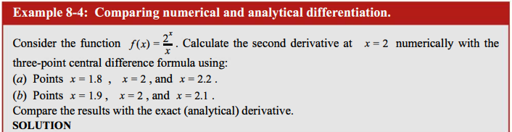

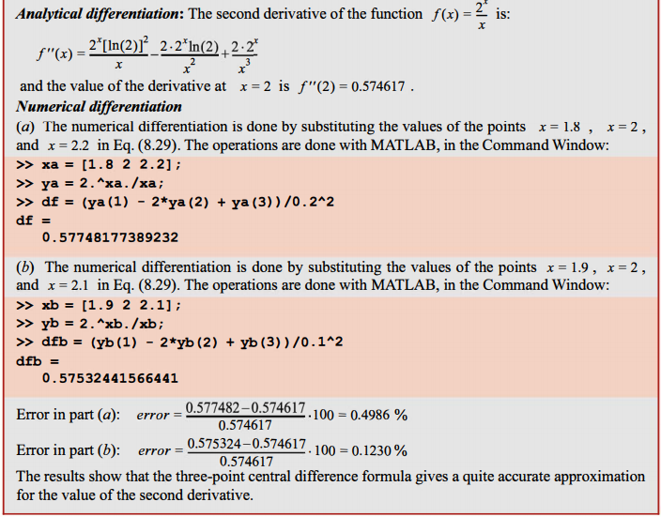

# Differentiation Formulae using Lagrange Polynomials

Differentiation formulae can also be derived using Lagrange Polynomials.

For the first derivative, the two-point central, three-point forward and three-point backward-difference formulae are obtained by considering three points $(x_{i},y_{i})$, $(x_{i+1},y_{i+1})$ and $(x_{i+2},y_{i+2})$.

The polynomial, in Lagrange form, that passes through these points is given by:

$f(x)=\frac{(x-x_{i+1})(x-x_{i+2})}{(x_{i}-x_{i+1})(x_{i}-x_{i+2})}y_{i}+\frac{(x-x_{i})(x-x_{i+2})}{(x_{i+1}-x_{i})(x_{i+1}-x_{i+2})}y_{i+1}+\frac{(x-x_{i})(x-x_{i+1})}{(x_{i+2}-x_{i})(x_{i+2}-x_{i+1})}y_{i+2}$

Differentiating this equation gives:

$f'(x)=\frac{2x-x_{i+1}-x_{i+2}}{(x_{i}-x_{i+1})(x_{i}-x_{i+2})}y_{i}+\frac{2x-x_{i}-x_{i+2}}{(x_{i+1}-x_{i})(x_{i+1}-x_{i+2})}y_{i+1}+\frac{2x-x_{i}-x_{i+1}}{(x_{i+2}-x_{i})(x_{i+2}-x_{i+1})}y_{i+2}$

The first derivative at any one of the three points $(x_{i},y_{i})$, $(x_{i+1},y_{i+1})$ and $(x_{i+2},y_{i+2})$ is obtained by substituting the corresponding value of $x$ into this equation.

The following are the three-point forward-difference, two-point central-difference and three-point backward-difference formulae respectively:

$f'(x_{i})=\frac{2x-x_{i+1}-x_{i+2}}{(x_{i}-x_{i+1})(x_{i}-x_{i+2})}y_{i}+\frac{x_{i}-x_{i+2}}{(x_{i+1}-x_{i})(x_{i+1}-x_{i+2})}y_{i+1}+\frac{x_{i}-x_{i+1}}{(x_{i+2}-x_{i})(x_{i+2}-x_{i+1})}y_{i+2}$

$f'(x_{i+1})=\frac{x_{i+1}-x_{i+2}}{(x_{i}-x_{i+1})(x_{i}-x_{i+2})}y_{i}+\frac{{2x_{i+1}-x}_{i}-x_{i+2}}{(x_{i+1}-x_{i})(x_{i+1}-x_{i+2})}y_{i+1}+\frac{x_{i}-x_{i+1}}{(x_{i+2}-x_{i})(x_{i+2}-x_{i+1})}y_{i+2}$

$f'(x_{i+2})=\frac{x_{i+2}-x_{i+1}}{(x_{i}-x_{i+1})(x_{i}-x_{i+2})}y_{i}+\frac{x_{i+2}-x_{i}}{(x_{i+1}-x_{i})(x_{i+1}-x_{i+2})}y_{i+1}+\frac{2x_{i+2}-x_{i}-x_{i+1}}{(x_{i+2}-x_{i})(x_{i+2}-x_{i+1})}y_{i+2}$

The advantage of these formulae is that points **do not have to be evenly-spaced**, however there is **no estimate for the magnitude of the error**.

# Differentiation using Curve-Fitting

Differentiation may also be performed by finding an analytic function that approximates the data. The value of the derivative at a point can then be found by **differentiating analytically**.

This procedure is preferred if there is a lot of scatter in the data. Curve-fitting smoothes out the scatter, and so enhances the accuracy of the estimate of the derivative.

However, unlike using the finite-difference formulae using the Taylor series expansion, there is **no error estimate**.

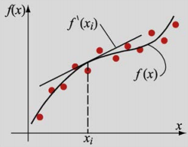

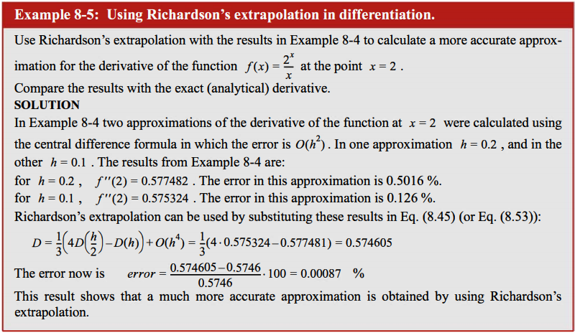

We have seen with finite-difference formulae derived using the Taylor series expansion that truncation errors of various orders of the spacing $h$ were obtained. Since for a discrete set of data points $h$ is fixed, it is not possible to reduce the error by reducing $h$. We can however, use a difference formula with higher-order truncation error to get a greater accuracy.

On the other hand, if the function to be differentiated is continuous, then we can reduce $h$ to get greater accuracy. However, there is also a round-off error resulting from the finite precision of the computer being used. This means that even though $h$ can be made vanishingly small, the round-off error remains or can even grow as $h$ is made smaller and smaller.

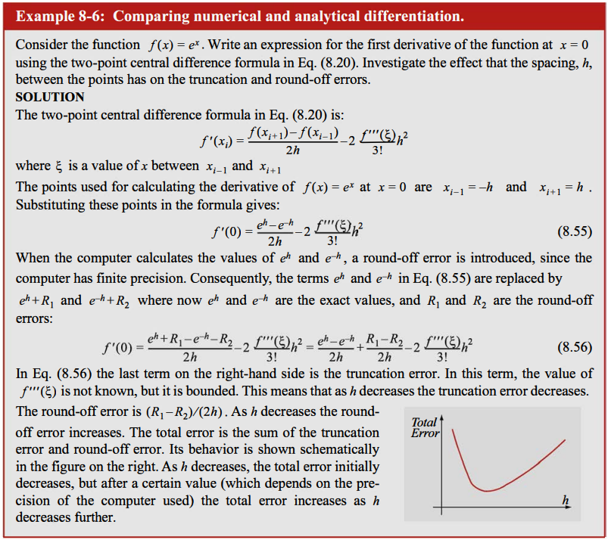

### Numerical Partial Differentiation

The finite-difference formulae obtained earlier can also be used to obtain **partial derivatives**.

For a function $f(x,y)$, the partial derivatives with respect to $x$ and $y$ at that point $(a,b)$ are:

$\frac{∂f(x,y)}{∂x}│_{x=a, y=b}=\lim_{x→a}\frac{f(x,b)-f(a,b)}{x-a}$

$\frac{∂f(x,y)}{∂y}│_{x=a, y=b}=\lim_{y→b}\frac{f(a,y)-f(a,b)}{y-b}$

This means that the finite-difference formulae for function of a single variable can be extended to calculating the partial derivatives with respect to a particular variable of functions of two or more independent variables, by holding the other variables constant.

An approximation for the partial derivative at the point $(x_{i},y_{i})$ with the two-point **forward-difference** formula is:

$\frac{∂f(x,y)}{∂x}│_{x=x_{i}, y=y_{i}}=\lim_{x→a}\frac{f(x_{i+1},y_{i})-f(x_{i},y_{i})}{h_{x}}$

$\frac{∂f(x,y)}{∂y}│_{x=x_{i}, y=y_{i}}=\lim_{x→a}\frac{f(x_{i},y_{i+1})-f(x_{i},y_{i})}{h_{y}}$

In the same way, the two-point **backward-difference** formula is:

$\frac{∂f(x,y)}{∂x}│_{x=x_{i}, y=y_{i}}=\lim_{x→a}\frac{f(x_{i},y_{i})-f(x_{i-1},y_{i})}{h_{x}}$ $\frac{∂f(x,y)}{∂y}│_{x=x_{i}, y=y_{i}}=\lim_{x→a}\frac{f(x_{i},y_{i})-f(x_{i},y_{i-1})}{h_{y}}$

and the two-point **central-difference** formula is:

$\frac{∂f(x,y)}{∂x}│_{x=x_{i}, y=y_{i}}=\lim_{x→a}\frac{f(x_{i+1},y_{i})-f(x_{i-1},y_{i})}{2h_{x}}$ $\frac{∂f(x,y)}{∂y}│_{x=x_{i}, y=y_{i}}=\lim_{x→a}\frac{f(x_{i},y_{i+1})-f(x_{i},y_{i-1})}{2h_{y}}$

The **second partial derivatives** with the **three-point central-difference** formulae are:

$\frac{∂^{2}f}{∂x^{2}}│_{x=x_{i}, y=y_{i}}=\frac{f(x_{i-1},y_{i})-2f(x_{i},y_{i})+f(x_{i+1},y_{i})}{h_{x}^{2}}$

$\frac{∂^{2}f}{∂y^{2}}│_{x=x_{i}, y=y_{i}}=\frac{f(x_{i},y_{i-1})-2f(x_{i},y_{i})+f(x_{i},y_{i+1})}{h_{y}^{2}}$

The second-order partial derivative can also be mixed:

$\frac{δ^{2}f}{δxδy}=\frac{δ}{δy}(\frac{δf}{δx})==\frac{δ}{δx}(\frac{δf}{δy})$

A finite-difference formula for the **mixed derivative** can be obtained by using the **first-order** finite-difference formulae for **partial derivatives**.

09 Numerical Integration

The length of a curve between points $a$ and $b$ is given by:

$L=\int_{a}^{b}{}\sqrt{1+{(f'(x))}^{2}}dx$

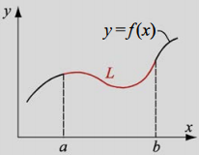

Another example is in calculating the thrust of a rocket which is expressed as a function of the exit-velocity of the exhaust and the density of the exhaust over the exhaust aperture.

$T=\int_{0}^{R}{}2πρ(r)V_{exit}^{2}(r)rdr$

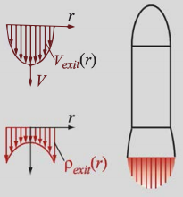

The general form of a **definite integral** (the antiderivative) is:

$I(f)=\int_{a}^{b}{}f(x)dx$**(9.1)**

where:

* $f(x)$, called the **integrand**, is a function of the independent variable $x$
* $a$ and $b$ are the **limits of integration**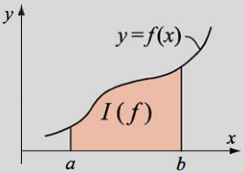

Graphically, the value of the integral corresponds to the **area under the curve** between $a$ and $b$ when we integrate over the $x$-axis.

The integrand is an analytical function or a set of discrete points (tabulated data). Numerical integration is needed when the integrand is discrete and / or where analytical integration is difficult, numerous or impossible.

### The Rectangle Method

The simplest approximation for $\int_{a}^{b}{}f(x)dx$ is to take $f(x)$ over the interval $x∈\left[a,b\right]$ as a **constant** equal to the value of $f(x)$ at either one of the endpoints.

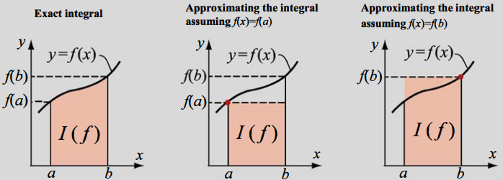

The integral is then:

$I(f)=\int_{a}^{b}{}f(a)dx=f(a)(b-a)$ or $I(f)=\int_{a}^{b}{}f(b)dx=f(b)(b-a)$

A more accurate method is to use the **composite rectangle method**:

* The domain $\left[a,b\right]$ is divided into $N$ subintervals
* The integrals over each of the subintervals are evaluated using the rectangle method
* The results are **summed** to get the integral over the **complete domain**

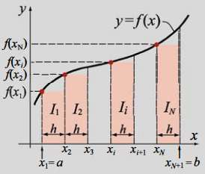

Then:

$I(f)=\int_{a}^{b}{}f(x)dx≈f(x_{1})(x_{2}-x_{1})+f(x_{2})(x_{3}-x_{2})+...+f(x_{n})(x_{n+1}-x_{n})=\sum_{i=1}^{n}{}\left[f(x_{i})(x_{i+1}-x_{i})\right]$

or when the subintervals have the **same width $h$** :

$I(f)=\int_{a}^{b}{}f(x)dx≈h\sum_{i=1}^{n}{}f(x_{i})$

### The Midpoint Method

An **improvement** to the rectangle method is the midpoint method.

Instead of approximating the integrand by the values of the function at $x=a$ or $x=b$, the value of the integrand at the **middle** of the interval $f(\frac{a+b}{2})$ is used:

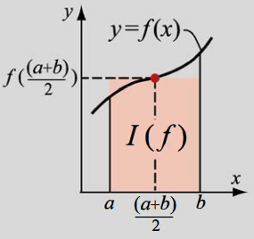

$I(f)=\int_{a}^{b}{}f(x)dx≈\int_{a}^{b}{}f(\frac{a+b}{2})dx=f(\frac{a+b}{2})(b-a)$

Again, this can be improved upon by dividing the domain into $N$ subintervals and performing a **composite integration**:

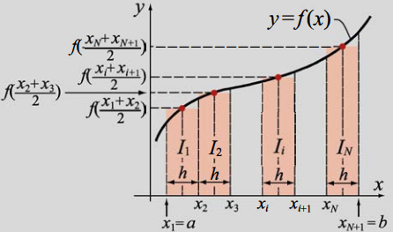

Mathematically, this is:

$I(f)=\int_{a}^{b}{}f(x)dx≈f(\frac{x_{1}+x_{2}}{2})(x_{2}-x_{1})+f(\frac{x_{2}+x_{3}}{2})(x_{3}-x_{2})+...+f(\frac{x_{n}+x_{n+1}}{2})(x_{n+1}-x_{n})=\sum_{i=1}^{n}{}\left[f(\frac{x_{i}+x_{i+1}}{2})(x_{i+1}-x_{i})\right]$

If each of the subintervals have the same length $h$ we can write:

$I(f)=\int_{a}^{b}{}f(x)dx≈h\sum_{i=1}^{n}{}f(\frac{x_{i}+x_{i+1}}{2})$

### The Trapezoidal Method

A refinement over the simple rectangle and midpoint method is to use a **linear function** to approximate the integrand over the interval of integration.

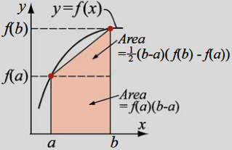

$I(f)=\int_{a}^{b}{}f(x)dx$**(9.1 again)**

The equation of a line connecting two points with $x$-ordinates $a$ and $b$ is:

$f(x)≈f(a)+(x-a)f\left[a,b\right]=f(a)+(x-a)\frac{\left[f(b)-f(a)\right]}{b-a}$**(9.8)**

Substituting equation (9.8) into (9.1) and integrating analytically gives:

$I(f)=\int_{a}^{b}{}\left(f(a)+(x-a)\frac{\left[f(b)-f(a)\right]}{b-a}\right)dx$

$=f(a)(b-a)+\frac{1}{2}\left[f(b)-f(a)\right](b-a)$

Simplifying the result gives the Trapezoidal rule:

$I(f)≈\frac{\left[f(b)-f(a)\right]}{2}(b-a)$

Again, a more accurate result can be performed by composite integration yielding the **composite trapezoidal method**.

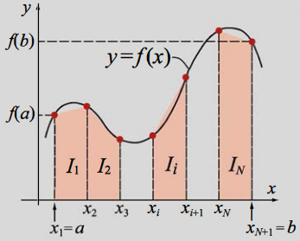

Mathematically:

$I(f)=\int_{a}^{b}{}f(x)dx=\int_{x_{1}=a}^{x_{2}}{}f(x)dx+\int_{x_{2}}^{x_{3}}{}f(x)dx+...+\int_{x_{n}}^{x_{n+1}}{}f(x)dx=\sum_{i=1}^{n}{}\int_{x_{i}}^{x_{i+1}}{}f(x)dx$

Applying the Trapezoidal method to each subinterval yields:

$I(f)=\int_{a}^{b}{}f(x)dx≈\frac{1}{2}\sum_{i=1}^{n}{}\left[f(x_{i})+f(x_{i+1})\right](x_{i+1}-x_{i})$

With equally-sized subintervals this can be reduced to:

$I(f)≈\frac{h}{2}\left[f(a)+f(b)\right]+h\sum_{i=1}^{n}{}f(x_{i})$

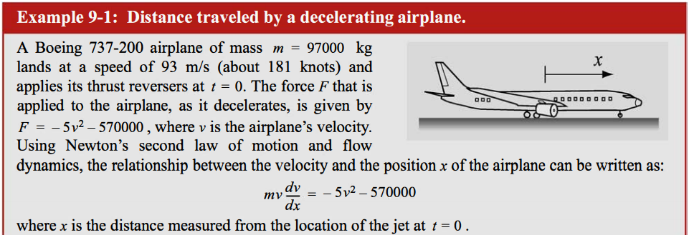

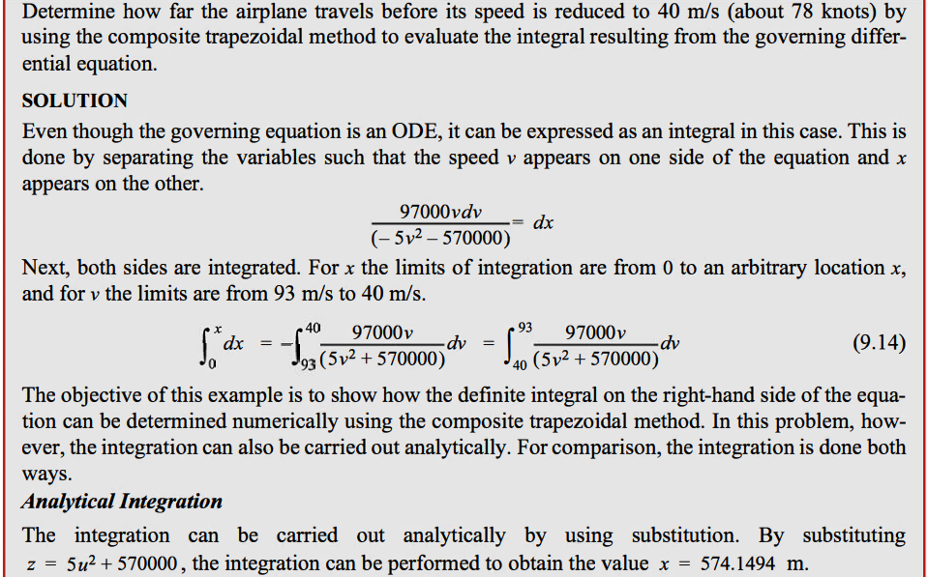

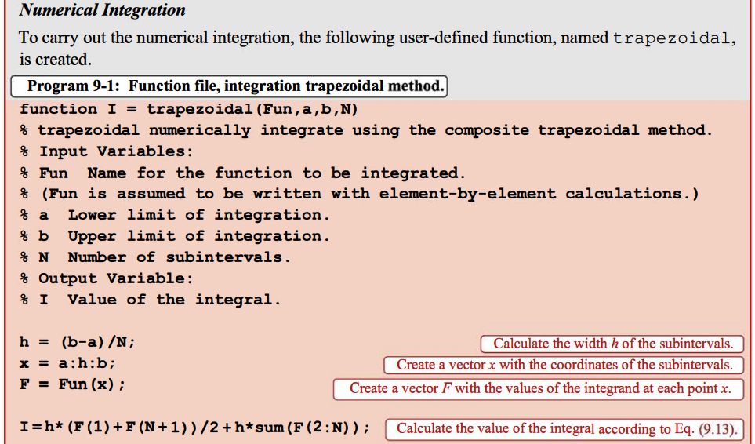

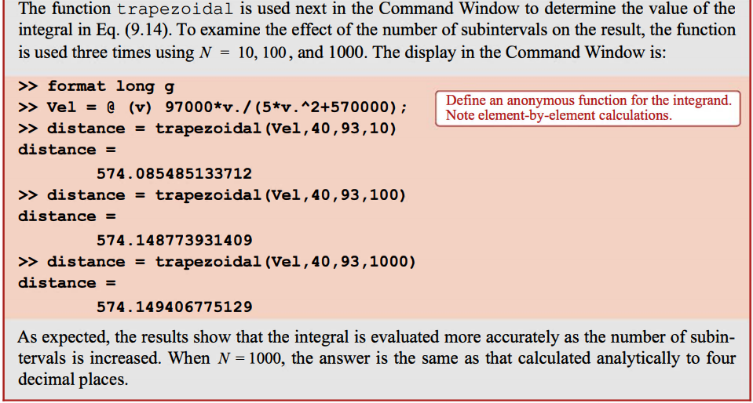

### Simpson’s Methods

With Simpson’s methods, the integrand is approximated by a **quadratic or cubic polynomial**.

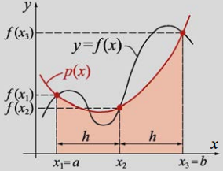

#### Simpson’s 1/3 Method

In this method, a quadratic polynomial is used to approximate the integrand.

Three points from the domain $\left[a,b\right]$ are used.

These are the endpoints $x_{1}=a$, $x_{3}=b$ and midpoint $x_{2}=\frac{a+b}{2}$.

The polynomial can be expressed in Newton’s form (it could be expressed in standard or Lagrange form):

$p(x)=α+β(x-x_{1})+γ(x-x_{1})(x-x_{2})$**(9.15)**

where $α$, $β$ and $γ$ are unknown constants evaluated by applying the conditions that the polynomial passes through the points $p(x_{1})=f(x_{1})$, $p(x_{2})=f(x_{2})$ and $p(x_{3})=f(x_{3})$.

These conditions yield:

$α=f(x_{1})$

$β=\frac{f(x_{2})-f(x_{1})}{x_{2}-x_{1}}$

$γ=\frac{f(x_{3})-f(x_{2})+f(x_{1})}{2h^{2}}$

where $h=\frac{b-a}{2}$.

Substituting these values for constants back into equation (9.15) and integrating $p(x)$ over the interval $\left[a,b\right]$ gives:

$I=\int_{x_{1}}^{x_{3}}{}f(x)dx≈\int_{x_{1}}^{x_{3}}{}p(x)dx=\frac{h}{3}\left[f(x_{1})+4f(x_{2})+f(x_{3})\right]=\frac{h}{3}\left[f(a)+4f(\frac{a+b}{2})+f(b)\right]$**(9.16)**

Simpson’s methods can be extended to a **composite form** by dividing the interval $\left[a,b\right]$ into $N$ subintervals of length $h$.

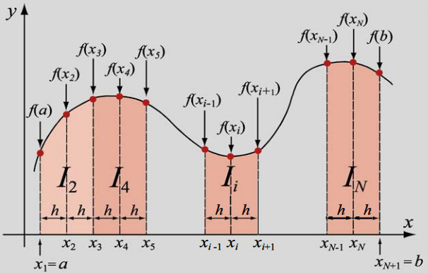

Since Simpson’s 1/3 method is applied to two subintervals at a time, it is necessary that the total number of subintervals is **even**. The integral over the whole interval is then written:

$I(f)=\int_{a}^{b}{}f(x)dx=\int_{x_{1}=a}^{x_{3}}{}f(x)dx+\int_{x_{3}}^{x_{5}}{}f(x)dx+...+\int_{x_{N-1}}^{x_{N+1}=b}{}f(x)dx=\sum_{i=2,4,6}^{N}{} \int_{x_{i-1}}^{x_{i+1}}{}f(x)dx$**(9.17)**

Rewriting equation (9.16) for two adjacent subintervals of equal length gives:

$I_{i}(f)=\int_{x_{i-1}}^{x_{i+1}}{}f(x)dx≈\frac{h}{3}\left[f(x_{i-1})+4f(x_{i})+f(x_{i+1})\right]$**(9.18)**

where $h=x_{i+1}-x_{i}=x_{i}-x_{i-1}$

Substituting equation (9.18) into (9.17) for each of the integrals and collecting similar terms gives the **composite Simpson’s 1/3 formula**:

$I(f)≈\frac{h}{3}\left[f(a)+4\sum_{i=2,4,6}^{N}{}f(x_{i})+2\sum_{j=3,5,7}^{N-1}{}f(x_{j})+f(b)\right]$

where $h=\frac{b-a}{N}$

#### Simpson’s 3/8 Method

In this method, a **cubic polynomial** is used to approximate the integrand.

A third-order polynomial can be determined using **four points**.

These are the endpoints $x_{1}=a$, $x_{4}=b$ and the two points $x_{2}$ and $x_{3}$ that divide the interval into three equal sections.

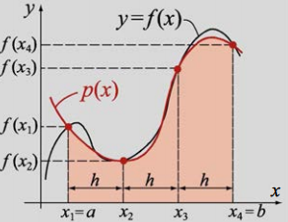

The polynomial can be written in the form:

$p(x)=c_{3}x^{3}+c_{2}x^{2}+c_{1}x+c_{0}$

where $c_{0}$ and $c_{3}$ are determined from the conditions that the polynomial passes through the points $p(x_{1})=f(x_{1}), ..., p(x_{4})=f(x_{4})$

Once these constants are determined, the polynomial can be easily integrated to give:

$I=\int_{a}^{b}{}f(x)dx≈\int_{a}^{b}{}p(x)dx=\frac{3}{8}h\left[f(a)+3f(x_{2})+3f(x_{3})+f(b)\right]$**(9.20)**

A **composite form** of Simpson’s 3/8 method can be achieved by dividing the interval $\left[a,b\right]$ into $N$ subintervals. In general, these can have arbitrary width but we concern ourselves with **equal spacings** here.

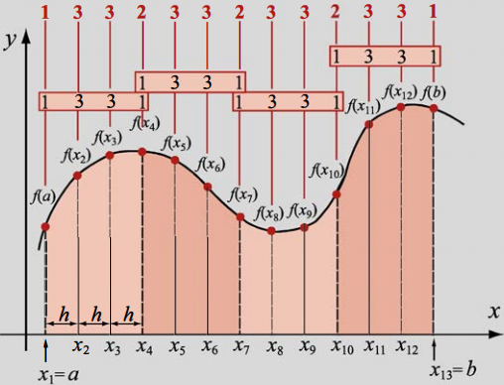

The integration in each group of three intervals is done by applying equation (9.20).

The integral over the whole domain is obtained by summing the integrals over the subintervals.

In general (where $N$ is divisible by 3):

$I(f)≈\frac{3h}{8}\left[f(a)+3\sum_{i=2,5,8}^{N-1}{}\left[f(x_{i})+f(x_{i+1})\right]+2\sum_{j=4,7,10}^{N-2}{}f(x_{j})+f(b)\right]$

### Gauss Quadrature

The general form of Gauss quadrature is a weighted sum:

$\int_{a}^{b}{}f(x)dx≈\sum_{i=1}^{n}{}C_{i}f(x_{i})$**(9.23)**

The coefficients $C_{i}$ are the weights and $x_{i}$ are specific points in the interval known as **Gauss points**.

We obtain weights $C_{i}$ and abscissae $x_{i}$ that make equation (9.23) exact for polynomials $x^{0},x^{1},x^{2},...$. The hope is that because these will yield exact results for polynomials, they can then be used for other functions that are well-approximated by polynomials.

Beginning with the domain $\left[-1,1\right]$ the form of Gauss quadrature is:

$\int_{-1}^{1}{}f(x)dx≈\sum_{i=1}^{n}{}C_{i}f(x_{i})$**(9.24)**

We now force equation (9.24) to be exact for the cases where $f(x)=1,x,x^{2},x^{3},...$

The number of cases that have to be considered depends on $n$.

For example, when $n=2$ we need to determine four values:

$\int_{-1}^{1}{}f(x)dx≈C_{1}f(x_{1})+C_{2}f(x_{2})$**(9.25)**

The four constants $C_{1}$, $C_{2}$, $x_{1}$ and $x_{2}$ are determined by enforcing equation (9.25) to be exact when applied to the following four cases:



$f(x)=1$ $\int_{-1}^{1}{}(1)dx≈2=C_{1}+C_{2}$

$f(x)=x$ $\int_{-1}^{1}{}xdx≈0=C_{1}x_{1}+C_{2}x_{2}$

$f(x)=x^{2}$ $\int_{-1}^{1}{}x^{2}dx≈\frac{2}{3}=C_{1}x_{1}^{2}+C_{2}x_{2}^{2}$

$f(x)=x^{3}$ $\int_{-1}^{1}{}x^{3}dx≈0=C_{1}x_{1}^{3}+C_{2}x_{2}^{3}$

This is a system of four equations with four unknowns so we can solve for $C_{1}$, $C_{2}$, $x_{1}$ and $x_{2}$. However, since the equations are nonlinear, multiple solutions can exist.

A particular solution can be obtained by imposing the condition that $x_{1}$ and $x_{2}$ are symmetrically located about $x=0$ i.e. $x_{1}={-x}_{2}$. This requirement implies that $C_{1}=C_{2}$.

Solving gives:

$C_{1}=C_{2}=1$

$x_{1}=-\frac{1}{\sqrt{3}}$

$x_{2}=\frac{1}{\sqrt{3}}$

$\int_{-1}^{1}{}f(x)dx≈C_{1}f(x_{1})+C_{2}f(x_{2})$**(9.25 again)**

Substituting back into equation (9.25) gives (for $n=2$):

$\int_{-1}^{1}{}f(x)dx≈f(-\frac{1}{\sqrt{3}})+f(\frac{1}{\sqrt{3}})$

This equation is exact for $f(x)=1$, $f(x)=x$, $f(x)=x^{2}$ and $f(x)=x^{3}$.

Example:

|  |
| --- |
| Let $f(x)=cos x$ Exact solution: $\int_{-1}^{1}{}cos x dx=sin x│_{-1}^{1}=sin(1)-sin(-1)=1.6829417$ The approximate value using Gauss quadrature is: $cos(-\frac{1}{\sqrt{3}})+cos(\frac{1}{\sqrt{3}})=1.67582366$ The error is within 4.5% of the exact solution. |

The accuracy of Gauss quadrature is increased by using a higher value of $n$.

For $n=3$, the equation has the form:

$\int_{-1}^{1}{}f(x)dx≈C_{1}f(x_{1})+C_{2}f(x_{2})+C_{3}f(x_{3})$**(9.28)**

In this case, six values have to be determined: $C_{1},C_{2},C_{3}$ and $x_{1},x_{2},x_{3}$.

The values are determined by enforcing equation (9.28) to be exact when $f(x)=1, f(x)=x, f(x)=x^{2}, ..., f(x)=x^{5}$

This results in a set of six equations with six unknowns. The values that are determined are given in the following table for this and a number of points up to $n=6$.

The general formula to use in conjunction with the table for Gauss quadrature is:

$\int_{-1}^{1}{}f(x)dx≈C_{1}f(x_{1})+C_{2}f(x_{2})+...+C_{n}f(x_{n})$

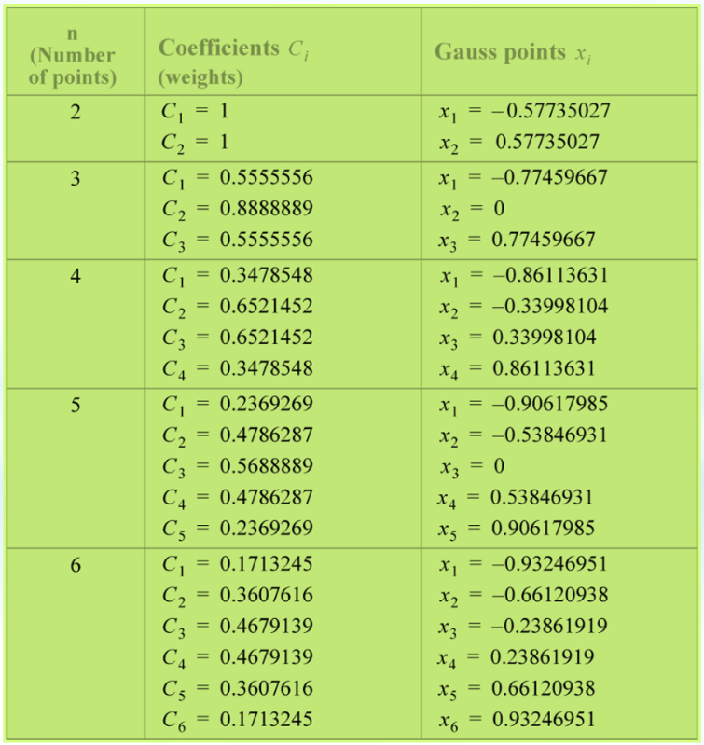

Using the same example as previous:

|  |
| --- |
| The approximate value using three-point Gauss quadrature is: $0.5555556cos(-0.77459667)+0.8888889cos(0)+0.5555556cos(0.77459667)=1.68285982$ This is almost an exact result. |

When the domain of integration is not $\left[-1,1\right]$, then a change of variables is necessary.

In other words, the integral $\int_{a}^{b}{}f(x)dx→\int_{-1}^{1}{}g(t)dt$.

The change in variable is:

$x=\frac{1}{2}\left[t(b-a)+a+b\right]$ and $dx=\frac{1}{2}(b-a)dt$

The Gauss quadrature is then performed using the transformed integral.

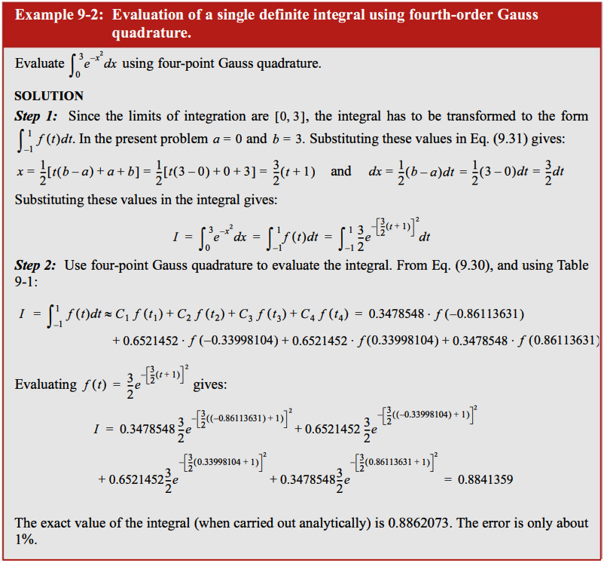

### Improper Integrals

So far we have considered integrals of well-behaved functions with finite limits. Situations arise however where functions are not well-behaved (discontinuous or singular) and / or have infinite limits.

#### Integrals with Singularities

If the integral $\int_{a}^{b}{}f(x)dx$ is singular at $x=c∈\left[a,b\right]$ then the integration can be performed over two intervals:

$\left[a,c\right]$

$\left[c,b\right]$

Mathematically, integrals that have a singularity at one of the endpoints may or may not have a finite value.

For example:

|  |
| --- |
| The function $\frac{1}{\sqrt{x}}$ is singular at $x=0$, but the integral of the function over $\left[0,2\right]$ equals 2.  That is: $\int_{0}^{1}{}\frac{1}{\sqrt{x}}dx=2$ |

An estimate of the integral can be obtained using any of the methods described here that do not use endpoints e.g. the composite midpoint method or Gaussian quadrature.

Otherwise, we can choose points very close to the endpoints that do not include the singularity, and then integrate over this domain.

On the other hand, $\frac{1}{\sqrt{x}}$ does not have a finite value.

#### Integrals with Unbounded Limits

Again, intervals with infinite limits can converge (have a finite value) or may diverge (have an infinite value). In the case of the former, the integration can be performed over a finite domain where the function has values that are **not** close to zero.

This is a typical situation where the integrand has a finite value over a relatively small domain, and close to zero everywhere else.

An example of this is the Gaussian PDF in statistics: $\int_{-∞}^{b}{}\frac{1}{\sqrt{2π}}e^{(\frac{-x^{2}}{2})}dx$

The computation of the integral stops where the successive iterations yield only a small (tolerable) change in the result.